

IP EXCHANGE

NUMBER PORTABILITY HANDBOOK

January 2024

Version History

Version History
Version 23.1 | Product Team | January 2024 | Include rejection action for the SOGEA Integrated Port within section 19.3.1
Version 23 | Product Team | January 2024 | Updates & inclusion of the SOGEA Integrated Port
Version 22 |  | February 2019 | Issued

Contents
1 Introduction 5
2 Outline of the Service 5
3 Pricing 6
4 IP Exchange Number Management Portal 6
5 Porting Scenarios 7
6 Lead Times 8
7 Geographic Number Porting (GNP) 9
7.1 Single Line Geographic Porting 9
7.1.1 Placing a Geographic Single Line IMPORT order 9
7.2 Multi-Line Geographic Porting 13
7.2.1 Multi-line Capacity Planning 13
7.2.2 Placing a Geographic Multi-Line IMPORT Order 15
7.3 Mixed Range Holder IMPORT order 21
7.4 Validation 22
7.4.1 Pre-Order Validation 22
7.5 Rejections 22
7.6 Re-present 23
7.7 Out of Hours Geographic Porting 23
7.8 Amendments 24
7.9 Cancelling 25
7.10 Day of Port 26
7.10.1 Fixed Time Ports 26
7.10.2 Real Time Activation/Auto-Postpone Ports 27
7.10.3 Bulk Activation (No Call for Port) 29
7.10.4 Port Completion 29
7.11 Problems during Porting & Emergency Restoration Requests 29
7.12 Portability Order Enquiry 30
7.13 Cease Previously Imported Numbers 33
7.14 Geographic Number Export 34
8 Non-Geographic Number Porting (NGNP) 35
8.1 Import 35
8.2 Problems during NGNP Porting & Emergency Restorations 40
8.3 Non-Geographic Number Export 40
9 CP Own Allocated Numbers Deployed on IP Exchange (EXPORT) 40
9.1 On-Net Export to IP Exchange 001 including Subsequent Port 41
9.2 Off-net Export including Subsequent Port 43
9.3 Return to Rangeholder Requests 49
9.4 Cancel Off-net Export 50
10 Directory Data 51
11 Emergency Services Database (ESDB) 51
12 Premises Move 52
13 Fault Handling and Repair 56
14 Notifications 56
15 Number Management Portal General Enquiries 59
16 Complaints Handling 59
17 Glossary of Terms 60
18 Useful Websites for Number Porting 60
19 APPENDIX 1 SOGEA Integrated Porting with IP Exchange A 62
19.1 Outline of the Service Changes 62
19.2 Ordering Process and Provision 62
19.3 Day of SOGEA Completed Install & IP Exchange Number Port 65
19.3.1 Real Time Activation/Auto-Postpone Ports 65
19.3.1 Fixed Time Ports 66
19.4 Fault Handling and Repair 66

Introduction

IP Exchange connects IP Communications Providers (CPs) to support VoIP to VoIP calling and calls to and from the Public System Telephone Network (PSTN), mobile, and international networks.

Number Portability enables end users to change their service or CP whilst keeping their existing telephone number.

This document provides details of the IP Exchange number porting service available to manage all porting activities on behalf of IP Exchange Type A billed communication providers (CPs) using our IP Exchange product.

This is achieved by utilising BT’s existing porting agreements with other Communication Providers (CPs) to import numbers onto the IP Exchange platform and programme our core routing engine to onward route the calls to the gaining CP (GCP). This means that numbers associated to a Type A IP Exchange CP are imported to BT’s CUPID 001.

The service also allows the export of any number associated to a Type A IP Exchange CP service that is,
- imported to the BT CUPID 001
- sub-allocated from a BT number range
- within a CP owned range managed on your IP Exchange Type A service

Outline of the Service

Our service consists of the following components:
- IP Exchange Number Management Portal
- IP Exchange service desk
- Order implementation and liaison with IP Exchange CPs and losing CPs as required.

For a number to be available to port it should be either
- a working number, or
- within the 31 calendar-day reactivation period if service has ceased and the line made ‘spare’.

CPs are responsible for ensuring the information they provide is accurate to facilitate the port; port requests will be rejected if the information is inaccurate or incomplete. It is imperative that the correct installation address is used when placing the order. This address is used initially to validate the order and, in the later stages of the order provision, to update the national Emergency Services Database (ESDB).

When a number is ported, the original installation is ceased. Any additional services provided by the current provider on the telephone line will also be ceased, e.g. broadband, and it may not be possible to re-establish ceased services.

Where a REDCARE service is provided on the existing telephone line, the GCP must arrange for the service to be removed before requesting the number to be ported.

Pricing

Refer to the IP Exchange contract, Schedule 3 Annex A for pricing information, this is available at,
https://www.btwholesale.com/pages/static/products-services/ip-exchange.htm#accProducts=3

IP Exchange Number Management Portal

Any CP wishing to use the porting managed service must first:
- Request access to www.btwholesale.com
- Select REGISTER a new account – external CP
- Request access to the IP Exchange App (see figure 1)

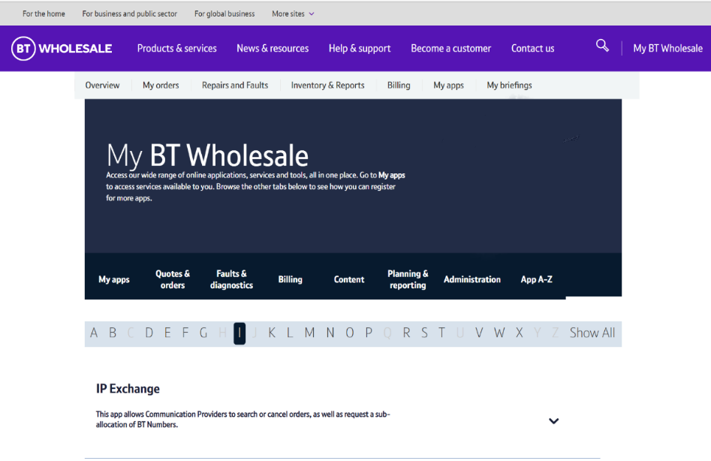

You will be kept informed via email as your request progresses and completes.

You can place/amend/cancel import and export requests once access to the IP Exchange app is granted.

Please note - use the ‘Log Out’ button when closing the application as this clears the cache/cookies - the next login may display old data if these remain.

Porting Scenarios

The porting service offers the import of single line numbers and multiline numbers i.e. a number range block or a single number at a single installation.

Import Scenario 1 | A BT telephone number (BT is the Range Holder) that is to be ported from the BT Public Switched Telephone Network (PSTN) or Voice over the Internet Protocol (VoIP) network to IP Exchange.
Import Scenario 2 | A BT telephone number, previously exported to another CP’s network, is to be ported to IP Exchange.
Import Scenario 3 | Another CP’s telephone number (other CP is the Range Holder), currently on their network, is to be ported to IP Exchange.
Import Scenario 4 | Another CP’s telephone number, already imported to the BT PSTN, is to be ported to IP Exchange.
Import Scenario 5 | Another CP’s end user telephone number, currently on a different CP’s network, is to be ported to IP Exchange.
Import Scenario 6 | A range of numbers in a block that belong to 2 or more different range holders or Current Network Operator, referred to as a Mixed Range Holder Port, i.e. Multiline orders only.
Import Scenario 7 | Porting of IP Exchange A CP own number Geographic and Non-Geographic ranges managed on IP Exchange to another IP Exchange CP. This includes Subsequent ports and Return to Rangeholder requests.

Currently we do not support integrated number porting.

The service offers the Exporting of BT sub-allocated numbers and CP own allocated numbers.

Export Scenario 1 | The export, from IP Exchange, of a CP own geographic number to a non-IP Exchange CP.
Export Scenario 2 | Export of a previously imported number to a non-IP Exchange CP.
Export Scenario 3 | Export of a previously imported BT range holder number to a non-IP Exchange CP.
Export Scenario 4 | Export of an IP Exchange BT sub-allocated number to  A) a non-IP Exchange CP  B) to WLR (Wholesale Line Rental - BTs Network)
Export Scenario 7 | Porting of IP Exchange A CP own number Geographic and Non-Geo Geographic ranges managed on IP Exchange to another IP Exchange CP. This includes Subsequent ports and Return to Rangeholder requests.

Lead Times

Geographic Importing Lead Times

Installation type | Lead Time (W/D) | Sub Port Leadtime (W/D)
Single Line | 4 | 7
Multi Line (30 Lines or less) | 7 | 10
Multi Line (31 lines – 150 lines) – Simple DDI | 10 | 13
Multi Line (151 lines or more) – Capacity check may be required | 17 | 20
Complex DDI | 22 | 25

Import Scenarios 4 and 6 are excluded from timescales for Multi Lines of 31 – 150 lines.
These are classed as Complex orders.

Geographic Exporting Lead Times

Installation type | Lead Time (W/D) | Sub Port Leadtime (W/D)
Single Line | 4 | 7
Multi Line (30 Lines of less) | 7 | 10
Multi Line (31 lines – 150 lines) – Simple DDI | 10 | 13
Multi Line (151 lines or more) – Capacity check may be required | 17 | 20
Complex DDI | 22 | 25

For exports that require increases to network capacity a revised porting date may be needed to allow time for network capacity to be increased.

Import and Export Scenario 7 orders are the responsibility of the rangeholder (RH) to meet the reduced lead times.

Non-Geographic Porting Lead Times

Installation type | Lead Time (W/D) | Subsequent Port Leadtime’s (W/D)
Single / Multiline | 7 | 10

Geographic Number Porting (GNP)

Single Line Geographic Porting

A single line port order must include one number and one losing CP (LCP) on the order request. Multiple LCPs at the same premises would require one order per LCP.

Placing a Geographic Single Line IMPORT order

From the IP Exchange App main menu, select SINGLE LINE IMPORT

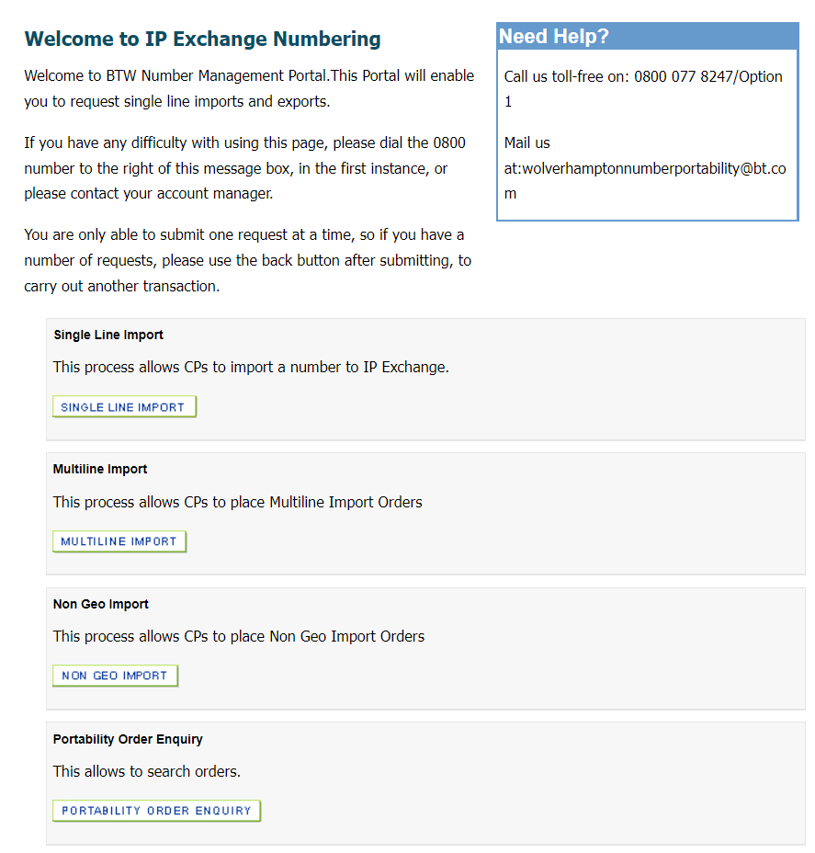

From the Single Line Import menu, select PLACE SINGLE LINE IMPORT

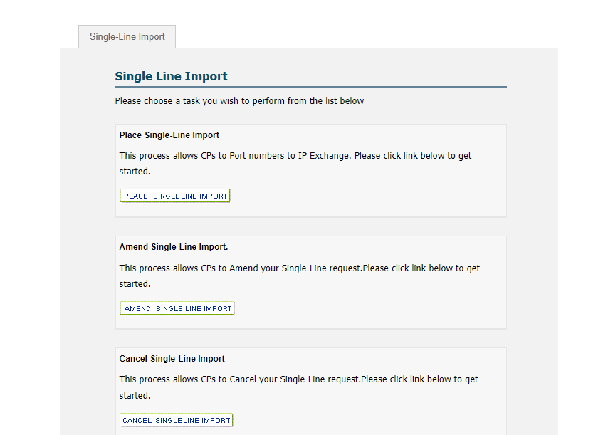

This will return the porting form with mandatory fields denoted by a red asterisk.

The Destination Group (DG) will auto populate. If you have more than 1 account, please overtype with the required DG.

Range Holder information is maintained by Ofcom. To check the Range Holder for a number you want to port, please check the Ofcom Numbering site before placing an order.

It is essential that the “Old Post Code” section is completed where end users are moving from their existing location. This is to ensure that the Emergency Services Database is correctly updated.

Fixed time port requests take place on the date and time as stated on the GCP order. Select a working day following the agreed lead times and the port time of choice between 08:00 and 17:00.

A real time activation port request provides the start date for a seven working day porting window and is always denoted by the activation time 19:45.

Number Transfer is only available where the Range Holder (RH) is 001 (BT) and the same end user is switching between services offered by the same provider. Ineligible requests will fail validation and be rejected.

A number transfer can be completed within a shorter lead time than a formal port request. A number transfer is only available where all the following conditions are met:

- The number(s) is in a BT allocated range
- BT is the Gaining Network Provider
- BT is the Losing Network Provider
- There is no change of retailer

Any request for a number transfer submitted where any of the above does not apply will be rejected following validation.

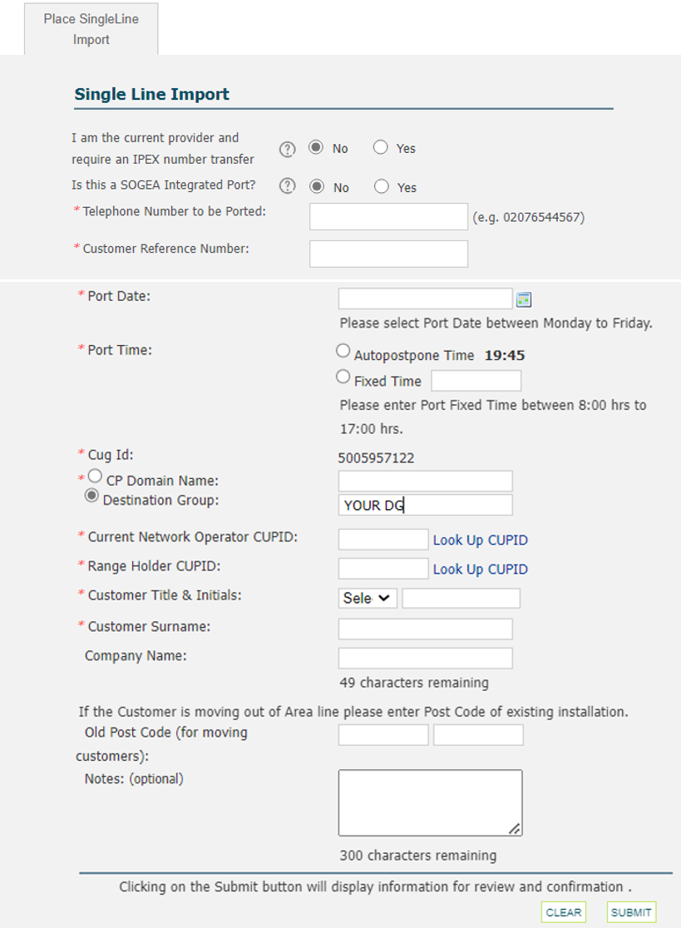

IPEX number transfer must be set as ‘No’ for a standalone single line import request. The SOGEA Integrated Port option will be displayed.

Select ‘No’ against the SOGEA Integrated option to follow the standalone IP Exchange Number port journey.

The default for both is set as ‘No’ and should remain so to place a standard single line import request.

For SOGEA Integrated please see Appendix 1 of this document.
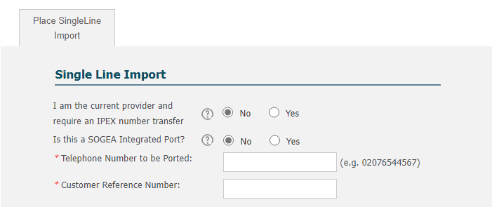

When correct details have been entered select “Submit”.

You will then be presented with the Single Line Import Details screen.

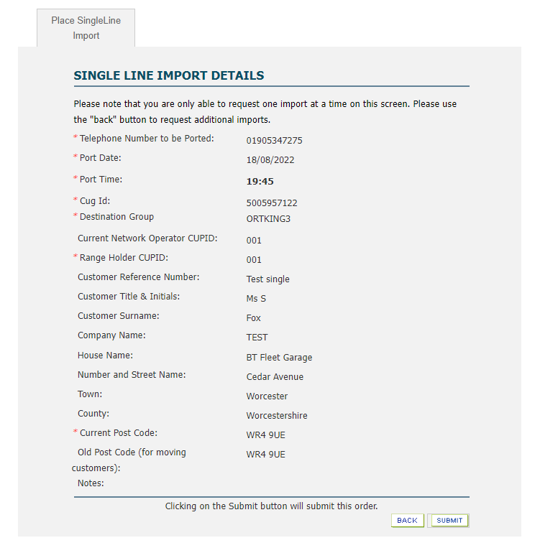

Check the details are correct and select “Submit”.

You will be presented with the Order Submitted screen with confirmation of your import order number.

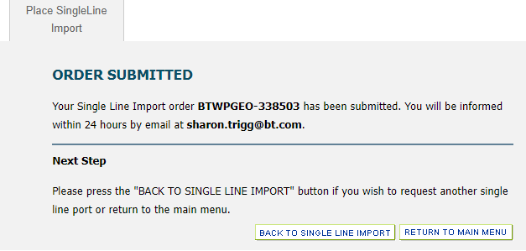

Email notifications are sent throughout the import and export journeys to acknowledge/confirm the action requested, and acceptance or rejection of the submitted order.

For bulk order placements of single line import/amend/cancel requests, we offer a secure data transfer service (SDEDs). Please contact the IP Exchange service desk via wolverhamptonnumberportability@bt.com for further details.

Multi-Line Geographic Porting

A multi-line port order covers a range of numbers working for a single customer at a single premises. The numbers can include a number range block but may have numbers associated to them that do not form part of the range. ‘Associated’ numbers normally appear on the same bill as the main billing number and are registered at the same address. ‘Other’ numbers are also registered at the same address but are billed separately.

A Complex DDI installation are those installations where only part of the DDI number block/range is to be ported. Please ensure that, as an IP Exchange CP, when you import a DDI block from BT these numbers are not to be utilised across more than one of your customers. Any numbers made spare need to be returned to the rangeholder.

Multi-line Capacity Planning

It is the responsibility of the RH and the GCP to ensure that the necessary capacity is available as degradation of service may occur to ported calls and other calls transiting the networks.

GCPs are reminded of their requirement to provide regular forecasts to BT IP Exchange as set out in the IP Exchange Product Handbook IP Exchange - Products & services | BT Wholesale to ensure that there is sufficient port capacity.

The RH will be required to conduct a capacity planning study for a porting request from a GCP where calls are delivered to 31 lines or more. This study will assess whether sufficient capacity exists within the RH network to carry the increase in traffic when porting the numbers. On receipt of the order the RH must provisionally accept or reject the order within 2 working days.

Once provisional acceptance is provided the capacity planning exercise will commence and be completed within 10 working days. On completion of the study the RH will inform the GCP of the result with an Accept or Reject for Capacity Planning timescales.

If the capacity planning study identifies the need to increase network capacity a revised porting date will be advised to the GCP with the reject code. The GCP may then re-schedule the porting date to the date quoted by the RH or beyond by submitting a re-present order. If the order is not re-presented by the GCP within 2 working days of completing the study, the required network capacity upgrade work will not be undertaken by the RH and the port order will time expire.

The following table shows some examples of installation types that require a capacity planning study.

Number of lines on the GCP Network | Capacity Planning Required
Multiline PBX (Private Branch Exchange) 31 lines and over | Yes
Combination of Multiline PBXs which collectively are 31 lines and over | Yes
Combination of Multiline PBXs and Single Line PBXs (i.e. S/L terminating on PBX equipment) which collectively are 31 lines and over. | Yes

Placing a Geographic Multi-Line IMPORT Order

From the IP Exchange App main menu, select MULTILINE IMPORT

From the Multiline Import menu, select PLACE MULTILINE IMPORT

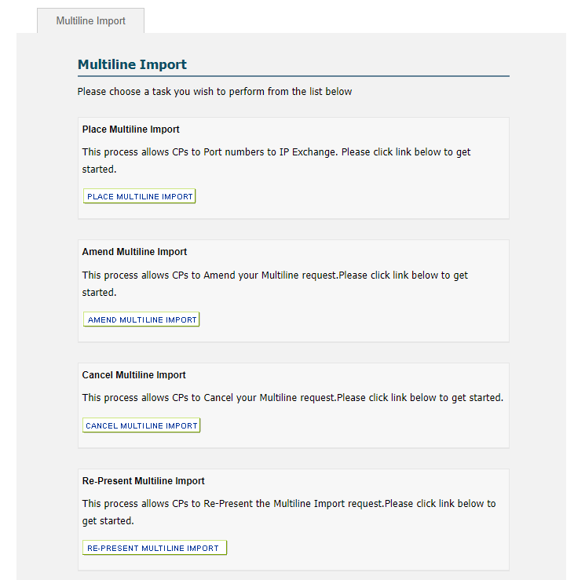

This will return the porting form with mandatory fields denoted by a red asterisk.

Fixed time port requests take place on the date and time as stated on the GCP order. Select a working day following the agreed lead times and the port time of choice between 08:00 and 17:00.

The action to be performed on the main billing number can be Retain, Cease or Port.

The DDI Letter of Authority (LoA) provides proof of ownership and customer authority to initiate the port order and allow data sharing between the current and gaining providers. It should be available on request.

The Destination Group (DG) will auto populate. If you have more than 1 account, please overtype with the required DG.

Range Holder information is maintained by Ofcom. To check the Range Holder for a number you want to port, please check the Ofcom Numbering site before placing an order.

It is essential that the “Old Post Code” section is completed where end users are moving from their existing location. This is to ensure that the Emergency Services Database is correctly updated.

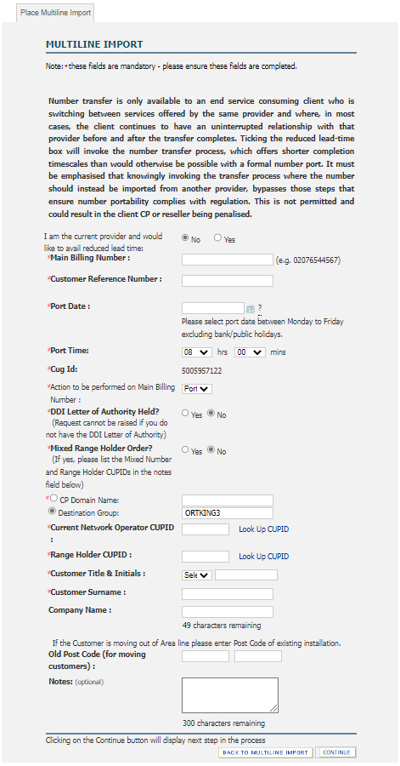

When correct details have been entered select “Continue” to move onto the Associated and Other numbers screen.

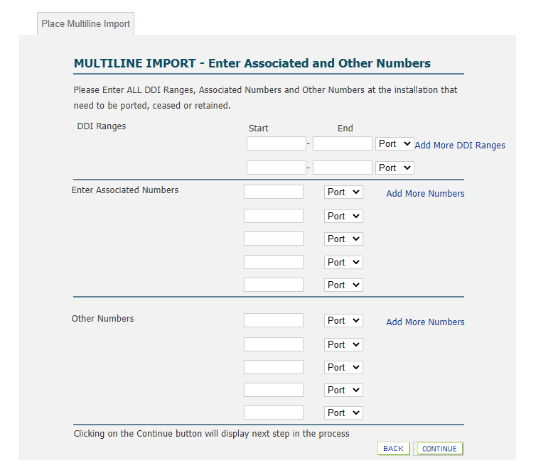

Enter any DDI ranges as a contiguous number block. Any associated numbers or other numbers are entered as single numbers.

The action to be performed on the number(s) can be Retain, Cease or Port for instances where only part of the block/range is to be ported.

Select “Continue”.

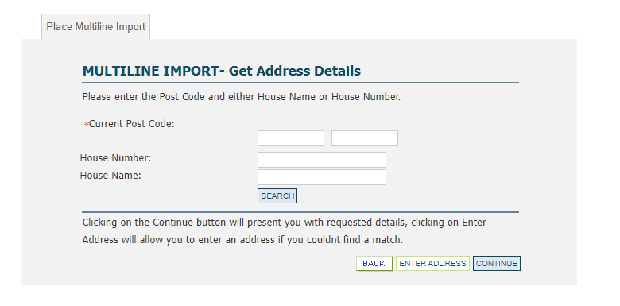
Enter the current postcode and house name/number, click the required match, and select “Continue”. If a match is not found, select “Enter Address” to manually enter the full address.

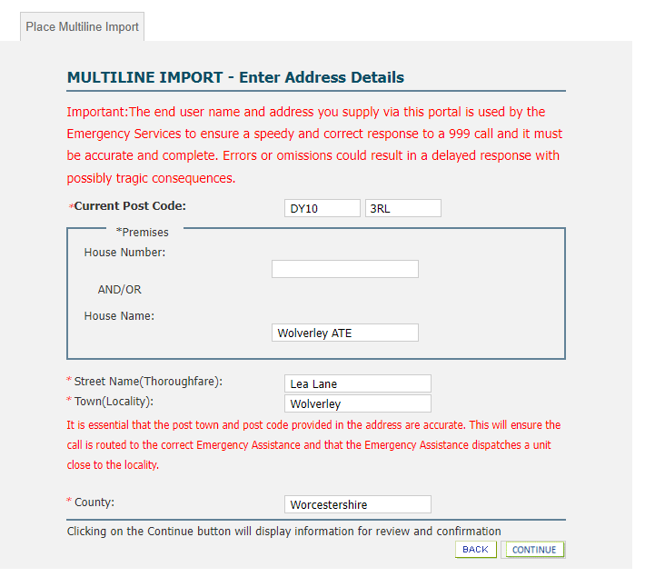
When correct address details have been entered select “Continue”. You will then be presented with the Confirm Activation screen.

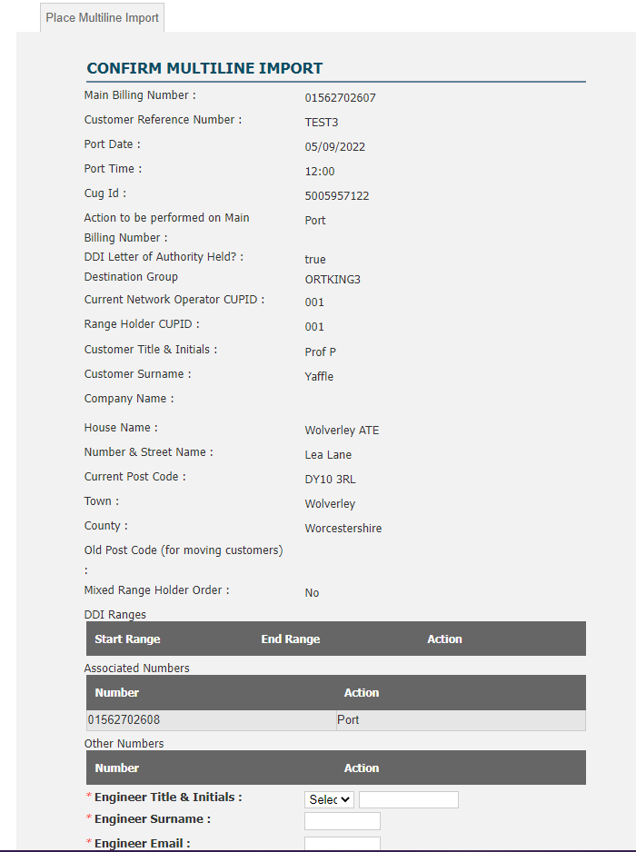

Check the correct details have been entered and select “Submit”.

You will be presented with the Order Submitted screen with confirmation of your import order number.

Email notifications are sent throughout the import and export journeys to acknowledge/confirm the action requested, and acceptance or rejection of the submitted order.

Mixed Range Holder IMPORT order

This supports the porting of multiline numbers from a single LCP that contains numbers owned by more than one range holder. This does not include Mixed LCP ports which should be submitted as separate orders.

As the GCP, select multiline import from the IP Exchange App main menu and select the option “Yes” against “Mixed Range Holder Order”.

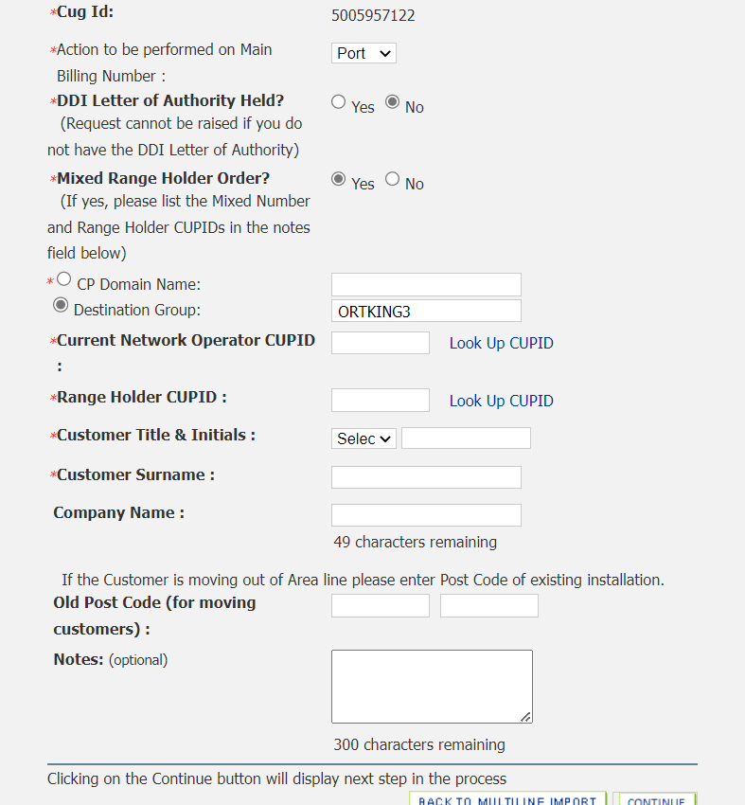

Enter the Main Billing number, DDI ranges, associated number(s) and other numbers as appropriate for a multiline request (applicable actions are port, retain and cease).
In addition, you must include the list of numbers to be ported, the range holder and associated CUPID information within the free text Notes field.

Date changes are permissible for mixed range holder port orders.

All relevant Keeping Customer Informed (KCI) emails for mixed range holder ports mirror those currently received for standard multiline orders.

Validation

The LCP will validate all port order requests against their records and accept/reject as appropriate.

Pre-Order Validation

The standard process for order validation can result in multiple rejections/delays where the information provided by the GCP does not match that of the LCP with no way of resolving the mismatch without the LCP’s direct help.

Pre-Order Validation (POV) is the process that provides the GCP with the ability to contact LCPs for information about a Geo Number that is to be ported.

CPs using the POV process are required to register with the Office for Telecommunications Adjudicator (OTA) who maintain a single contacts register which is accessible via the OTA website. Once registered, CPs may use the POV process to progress their own business multi-line or single-line orders (as GCPs) on the understanding that they reciprocate on other occasions when they are the Losing CP (LCP).

Please download the http://www.offta.org.uk/best-practice-guide Pre-order validation process document (from within the Geographic number porting process documents section).

Rejections

Orders can only be rejected based on incorrect or missing information being presented by the GCP. LCPs cannot override an end user customer’s right to port their number(s) even where service has been suspended by the CP e.g. for non-payment of bills.

All rejections are generated by the LCP and returned to the IP Exchange service desk for onward transfer to the GCP. Our jeopardy management team will follow up on all open orders, adding progress notes for you to review via the ‘Portability Order Enquiry’ option within the IP Exchange Number Management Portal (see section 7.12).

If the port request is rejected, we will provide details of the rejection codes as stated within the GNP end to end process manual GEOGRAPHIC NUMBER PORTABILITY (GNP) END TO END PROCESS MANUAL (offta.org.uk). The guide to resolving rejections can found on the IP Exchange Number Management Portal via the Frequently Asked Questions (FAQ) section number-porting-rejection-guide.pdf (btwholesale.com).

Due to the nature of the porting process and the date when responses are received from the LCP and/or RH, accept or reject responses may be returned in multiple files. These may not be in the order sequence that was originally presented to the IP Exchange service desk.

Re-present

A rejected single line order must be resubmitted via a new order.

A rejected multiline order can be corrected and resubmitted via a represent order request. Rejected multiline orders can have a re-present returned within 2 working days from the rejection of the main order. The Customer Required Date (CRD) should follow standard lead times so you may need to amend the port date on the represent request.

Rejected multiline orders, which do not have a valid re-present returned within 2 working days from the rejection will be considered time expired and a new request will need to be raised.

Resubmit requests are submitted via the IP Exchange Number Management Portal, selecting the Re-Present option within the Multiline Import menu. Search via the rejected order reference number or the telephone number to be ported.

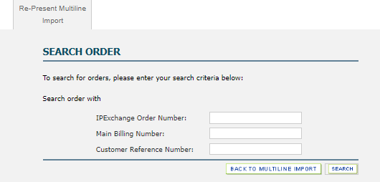

Out of Hours Geographic Porting

Out of hours (OOH) porting is dependent on resource availability from all associated parties. Charges apply during weekday evenings from 17:00-08:00 next morning, and all-day Saturday. Sunday OOH is out of scope.
Out of hours charges will be quoted on application.

A minimum of one months’ notice is required for an OOH port. Date changes for an OOH will require a minimum of 5 working days.

The IP Exchange Number Management Portal will not accept OOH port requests. The GCP must therefore submit a standard in hour’s port request for the nearest working day to the required port date. The time of the request will be 14.00hrs. Once acceptance has been received for the in hours port, the GCP will submit an OOH porting request along with an AX form via email to the IP Exchange service desk at wolverhamptonnumberportability@bt.com.

The AX form contains all the porting information including the required date/time for the ports and business justification. Once completed, the form should be sent as a PDF. The GCP can obtain the most recent AX form from their Account Manager/ Sales Specialist who will aid completion.

Email notifications will be sent advising the outcome and necessary next steps.

Amendments

An accepted port request can be amended up to 16.00, on the last working day prior to the Customer Required by Date (CRD). Porting date/time changes must meet the agreed lead-times. If any other information is required to be amended, then the original order must be cancelled, and a new request submitted.

Please note that date changes are not supported for Import Scenario 4 orders.

Change orders are submitted via the IP Exchange Number Management Portal, selecting the Amend option within the Single Line or Multiline Import menus as appropriate. Search via the order reference number or the telephone number to be ported.

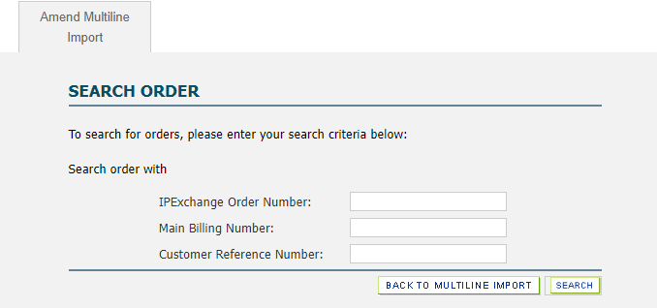
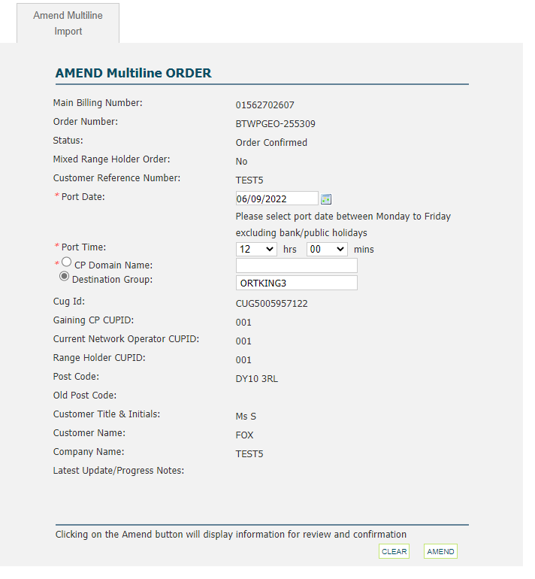

Cancelling

An accepted port request can be cancelled up to 16.00 on the last working day prior to the Customer Required by Date (CRD).

A Cancel Own (COW) is generated by the GCP to cancel an order that has been accepted but not yet activated.
COW requests are submitted via the IP Exchange Number Management Portal, selecting the Cancel option within the Single Line or Multiline Import menus as appropriate. Search via the order reference number or the telephone number to be ported and enter the reason for the cancellation.

Once cancelled, a new porting request must be submitted for the number if it is required to be ported in the future.

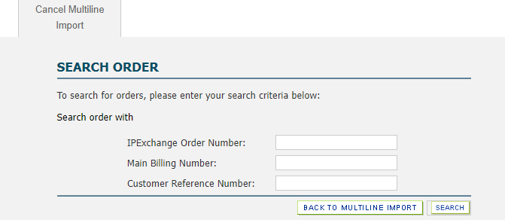

Cancel Other (COT) is generated by the LCP, usually where an end user has advised they no longer wish to port. The LCP should send a COT Number Portability Order Request (NPOR) to the IP Exchange service desk wolverhamptonnumberportability@bt.com to advise the export request should be cancelled. This will be sent on to you as the GCP.
The NPOR template can be found via App-B.pdf (offta.org.uk).

Day of Port

Fixed Time Ports

Single fixed time port requests automatically take place on the date and time as stated on the GCP order.
The Range Holder will apply the IP Exchange Porting Prefix in their network for the number to be ported.
The IP Exchange routing engine will be configured for that number at the time indicated on the porting order.
BT cannot guarantee exact synchronization between these two actions.

Multiline fixed time port requests require the following two actions to be conducted by the GCP to trigger the port -
- initiate the transfer of service with the IP Exchange service desk via eChat Contact us | BT Wholesale
- configure on the IP Exchange platform via the Configure Multiline Import option from the Multiline Import menu.

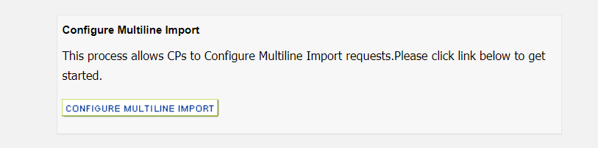
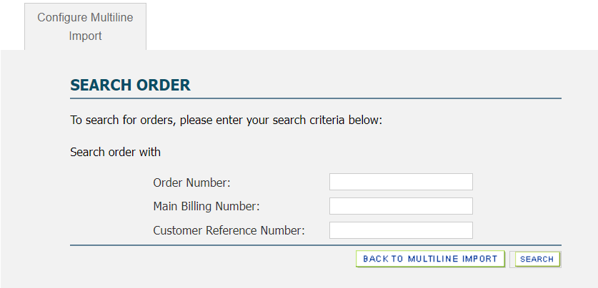

Both actions must take place and will ensure the numbers to be ported are configured on the IP Exchange Core Routing Engine, and the RH is advised to apply the IP Exchange Porting Prefix in their network.
Failure to complete one or the other of these actions will result in service issues.

There is a time limit of 3 hours to configure/activate the number porting order once the time window has opened, i.e. Port time is 10am you will need to configure/activate by 1pm. Failure to activate the port within the 3-hour window will cause the order to time expire and you will need to submit a new order.

You will be unable to configure/activate the multiline number porting order if the port time has not been reached.

Real Time Activation/Auto-Postpone Ports

Where the GCP has requested a Real Time Activation/Auto-postpone for a single line port, the date given on the porting request is the start date of the seven working day auto-postpone period. This allows the GCP a period of flexibility without having to raise a new porting order to the LCP. A real time activation (RTA) order is denoted by the activation time as 19:45. Ports can be activated up to 7 working days past the original requested date.

There are two actions required of the GCP to activate a real time activation port. The GCP must

- initiate the transfer of service with the IP Exchange service desk via eChat Contact us | BT Wholesale
- activate the number via the IP Exchange Number Management Portal using the ‘Activate Single Line Import’ option from the Single Import menu. This will generate an email to notify the Range Holder to export the number.

Both actions must take place and will ensure the numbers to be ported are configured on the IP Exchange Core Routing Engine, and the RH applies the IP Exchange Porting Prefix in their network.
Failure to complete one or the other of these actions will result in service issues.

Select the “Activate Single Line Import” option from the Single Import menu. Select “Submit”.
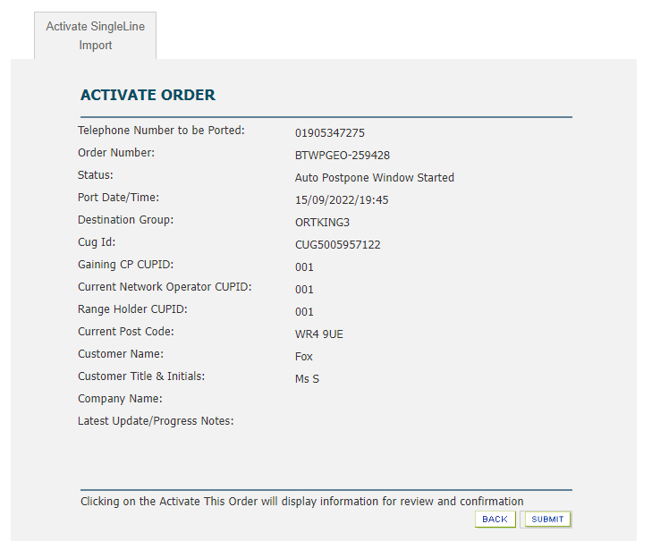

Select “Confirm”.

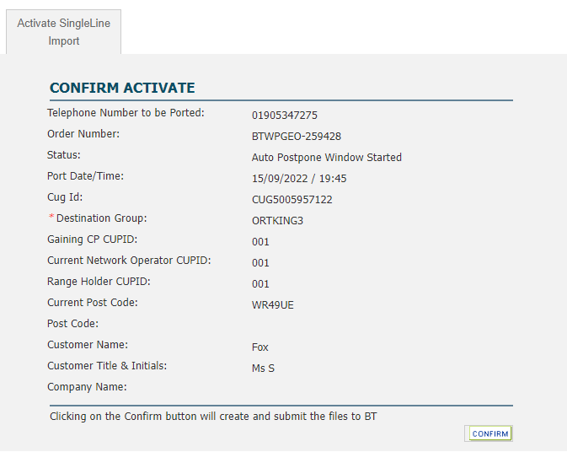

Up to three email reminders are sent from the CRD onwards advising the porting window has started. A single date change can be submitted once the original port start date has passed.

Failure to activate the port before the end of the porting window will cause the order to time expire and you will be advised to submit a new order if the port is still required.

Bulk Activation (No Call for Port)

The eChat option will accept up to three activation requests per chat. Where the GCP has more than three geographic ports requiring activation on the same day, the batch file bulk activation ‘No Call for Port’ process is available as a quicker alternative to multiple eChat’ s. This process can be used for activations of both fixed time multiline and auto postpone single.

Contact wolverhamptonnumberportability@bt.com to request registration for this process.

Once registered, you will receive a daily report of the ports due the following day. If no changes are highlighted, the team will trigger each of those requests on the day of port and share the completion notice once done.

Please note that Single fixed time port requests take place automatically and should not be included on the batch file spreadsheet.

Port Completion

Once the port has taken place, the GCP will receive an e-mail confirming the port request is now complete. The billing update will be triggered, and an update sent to the Emergency Services Database, using the name and address information supplied within the order.

Problems during Porting & Emergency Restoration Requests

GCPs should contact the IP Exchange service desk via eChat Contact us | BT Wholesale selecting the early life failure option if a problem occurs within 48 hours after port completion that they attribute to the BT service or the LCP network. The IP Exchange service desk will check if there are any IP Exchange platform issues that could be causing the problem, before liaising with the LCP.

Should the request for investigation be outside of the initial 48 hours following port completion, please raise a fault via the BT Wholesale Voice Products Ordering and Support Systems app accessed via www.btwholesale.com.

The Emergency Restoration Order can be used by the GCP to restore service to a ported customer when full service has not been provided following the attempted port. Any request for Emergency Restoration will be dependent upon the LCP agreeing to take the number back.

Emergency Restorations (EMRs) may be requested up to close of business the day following the activation of the port.

These requests can be made by completing an NPOR form, with the order type set at ‘EMR’, and emailing the IP Exchange service desk wolverhamptonnumberportability@bt.com, quoting the telephone number to be restored. The GCP should also contact the IP Exchange service desk via eChat Contact us | BT Wholesale selecting the emergency restore option.

The NPOR template can be found via App-B.pdf (offta.org.uk).

The IP Exchange service desk will request the Emergency Restoration and will inform the GCP if the LCP has agreed.

There are several scenarios where an Emergency Restoration will not be possible because the original access line is not available to the LCP. These include,

- Where the end-user has moved to a new address as the LCP will not have an access line available
- Access lines that have been fully unbundled (LLU)
- Wholesale Line Rental on a ‘stop sell’
- Subsequent Portability, as this will require data to be restored on more than one network. It is expected that Range Holders (where not the LCP) will assist as promptly as possible and will be contacted by the GCP only. This includes Scenario 4 orders where a RH number, currently on import to BT, is then subsequently ported to IP Exchange

Portability Order Enquiry

Use the Portability Order Enquiry option from the main menu to track the status of the porting orders you have placed and to view any progress notes added by the IP Exchange service desk.

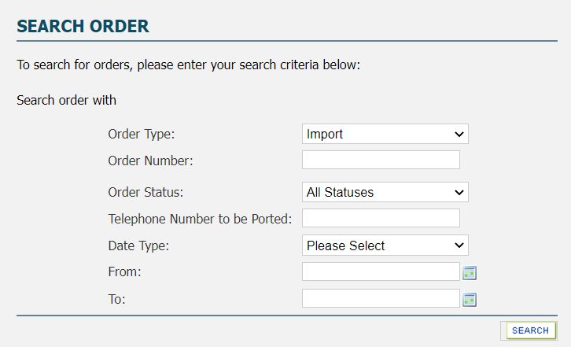

Filters can be added against the order type, status, and dates to reduce the search results returned.

The following screenshot shows two historic orders against the telephone number searched – a cancelled order and a more recent completed order.

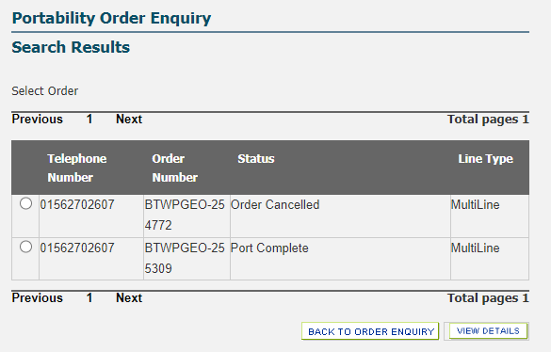

Select the radio button against the required order and select ‘View Details’ to see the see the order information with the latest update/progress notes from the IP Exchange service desk at the bottom of the screen.

The following screenshot shows the view of the ‘Port Complete’ order with the latest progress notes from the IP Exchange service desk referring to the call to port via eChat.

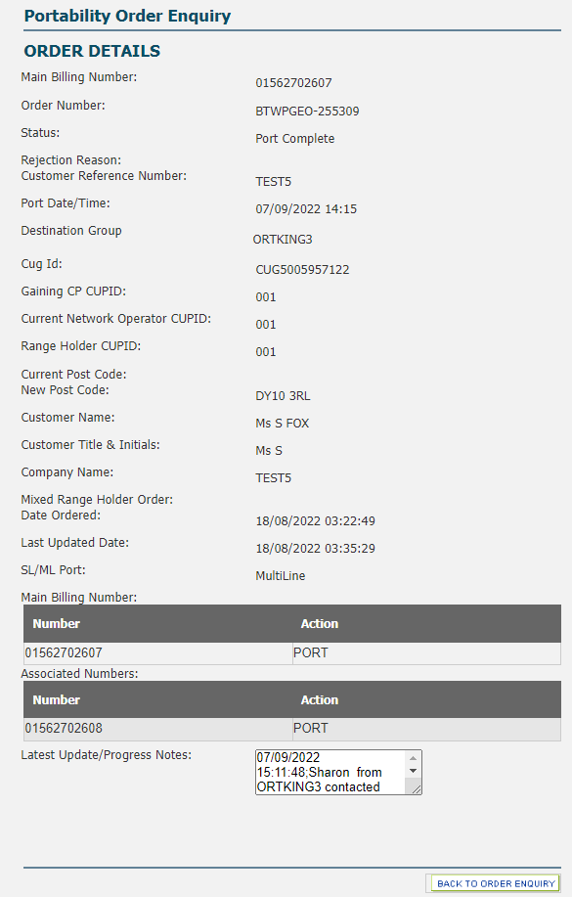

Cease Previously Imported Numbers

The Cease Import option via the main IP Exchange menu is used to allow CPs to cease numbers previously imported on to a Type A IP Exchange service that are no longer required.

A cease order should not be submitted in advance of the service being ceased by the end user customer as, once raised, a cease order cannot be amended or cancelled.

Please note a sub allocated number should be deactivated via the sub-allocation menu.

Enter the telephone number you wish to be ceased from your IP Exchange Type A service and select the required cease date/time with a minimum lead time of 24 hours. Select “Continue”.

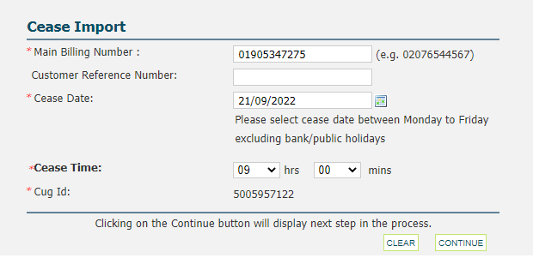

You will be presented with the Confirm Cease Import screen. Select “Submit”.

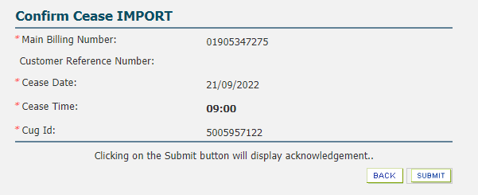

You will be presented with the submission screen confirming the order reference number.
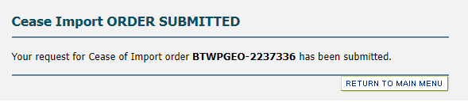

The completion notice for the cease will be sent to you as the LCP once the number has been removed from all systems including ESDB, and the number moves to a quarantined status. An end user customer has the right to port a number(s) up to one month (31 calendar days) after their service has been ceased. Please note we will start the right to port countdown from the moment IP Exchange receives your cease request irrespective of the time already lapsed for the end user.

Please ensure that, as an IP Exchange CP, when you import a DDI block from BT these numbers are not to be utilised across more than one of your end user customers. Any numbers made spare need to be returned to the rangeholder.

Cease orders for Multiline installations with associated DDI ranges should be submitted using an NPOR via the IP Exchange service desk on wolverhamptonnumberportability@bt.com.

Geographic Number Export

The service allows the export of any number that has been imported to the BT CUPID 001, any number that has been sub-allocated from a BT number range, or any number from a CP owned range managed on the IP Exchange Type A service.

Following acceptance of a number export request for a previously imported number or for a sub allocated number, the BT IP Exchange service desk will provide you as the LCP with an Advice of Transfer (AOT) email notification to advise you when the export is due to take place.

If you as the LCP successfully retains your end user customer, you should send a NPOR – order type Cancel Other (COT) - to the IP Exchange service desk via wolverhamptonexport@bt.com to advise the export request should be cancelled. This will be sent to the GCP.
The Number Portability Order Request (NPOR) template for geographic numbers can be found via App-B.pdf (offta.org.uk).

Where you as the IP Exchange Type A CP have sub allocated numbers to a Reseller and an export has been requested, it is your responsibility to inform the Reseller of the port date/time.

Please see the CP Own Allocated Numbers section 9 within this document regarding the porting of numbers from a CP owned range managed on the IP Exchange platform.

Non-Geographic Number Porting (NGNP)

IP Exchange can import / export non-geographic numbers e.g. UK numbers starting with 03*, 08* and 09* numbers.

Import

NGN orders are submitted via the Number Management Portal following a similar format to the geographic porting.

From the IP Exchange App main menu, select NON GEO IMPORT followed by PLACE NON GEO IMPORT

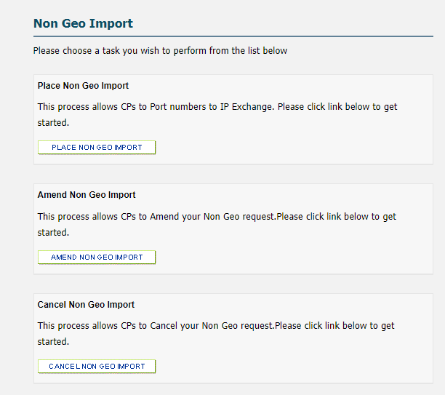

This will return the porting form with mandatory fields denoted by a red asterisk.

The action to be performed on the main billing number can be Retain, Cease or Port.

A Dated port is denoted by the activation time as 00:01 on the date specified and will take place between the standard porting times of 00:00-04:00.

A Timed port request take place on the date and time as stated on the GCP order. Select a working day following the agreed lead times and the port time of choice between 08:00 and 18:00.

Range Holder information is maintained by Ofcom. To check the Range Holder for a number you want to port, please check the Ofcom Numbering site before placing an order.

The customer details must match the person who has signed the Customer Letter of Authority (CLoA).
The account number must be submitted as it appears on the end user invoice for each number to port.

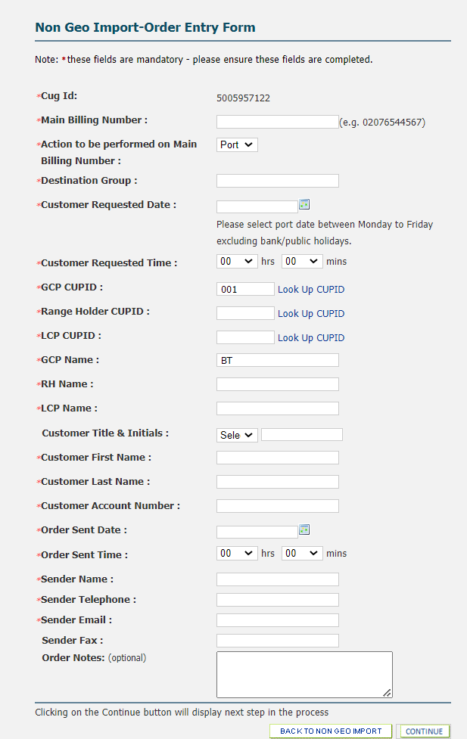

When correct details have been entered select “Continue” to move onto the Enter Ranges and Other Numbers screen.
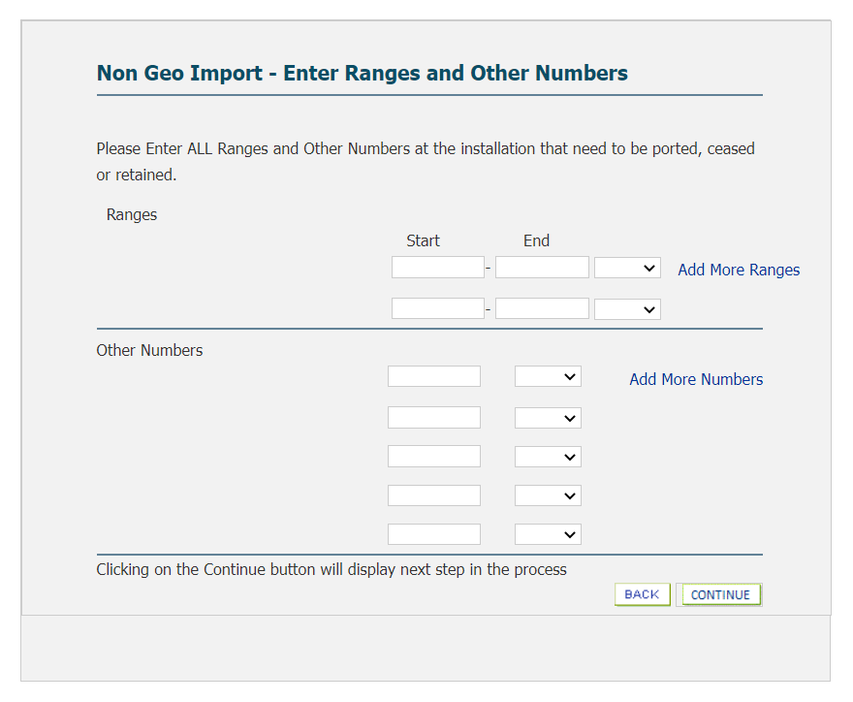
Enter any ranges as a contiguous number block. Any other numbers are entered as single numbers.

Click ‘Add more’ for additional fields to include more numbers as required.

The action to be performed on the number(s) can be Retain, Cease or Port for instances where only part of the DDI number block/range is to be ported.

Select “Continue”.

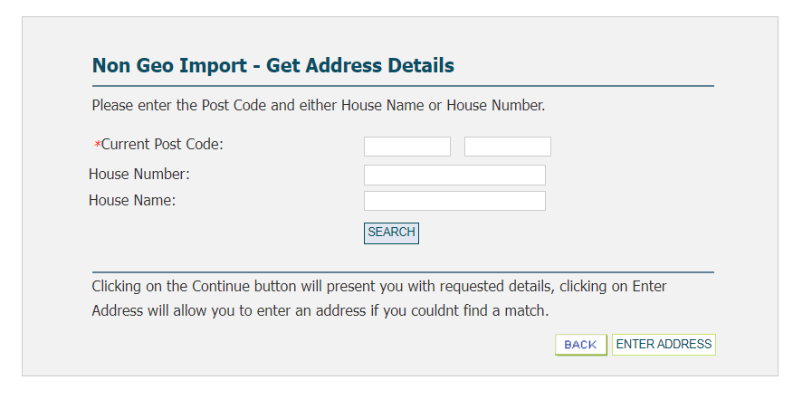
Enter the current postcode and house name/number, click the required match, and select “Continue”.
If a match is not found, select “Enter Address” to manually enter the full address.

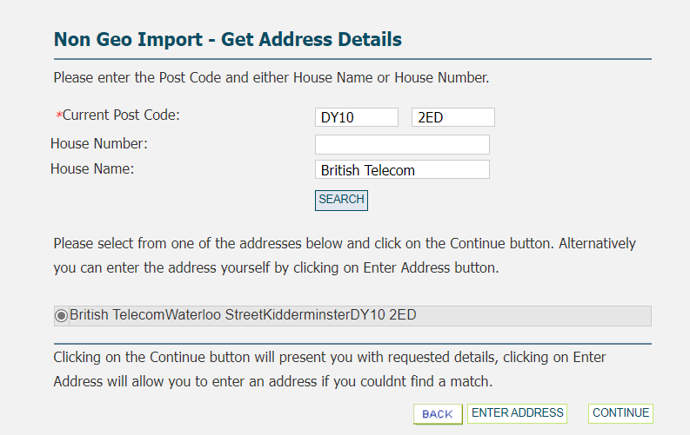

This information is used to keep the Emergency Services Number Database (ESDB) up to date.

When correct address details have been entered select “Continue”.

You will then be presented with the Order Acknowledgement screen with confirmation of your import order reference.

Select “Continue”

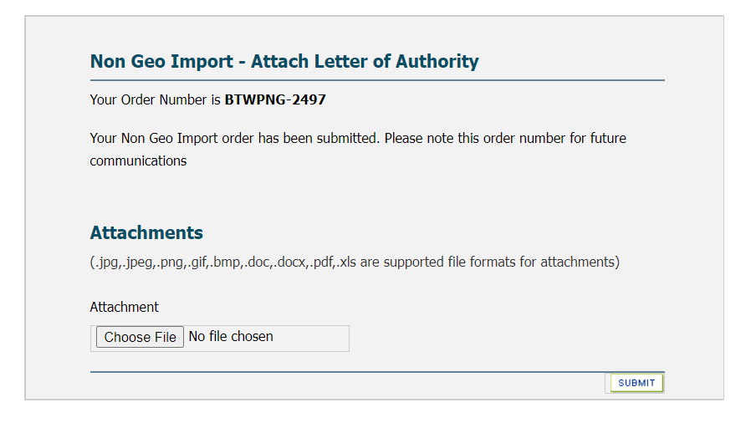
Each NGN order must be submitted along with a signed and dated Customer Letter of Authority (CLoA/LoA). The CLoA provides proof of ownership and customer authority to initiate the port order and allow data sharing between the current and gaining providers.
The name/address details to be used for BT as the GCP is BT IP Exchange, 1 Braham Street, London, E1 8EE.

The current version of the CLoA can be found via http://www.offta.org.uk/__data/assets/word_doc/0035/195875/App-R2-New-CLoA-Template.docx

“Choose File” to attach the signed and dated copy of the CLoA.

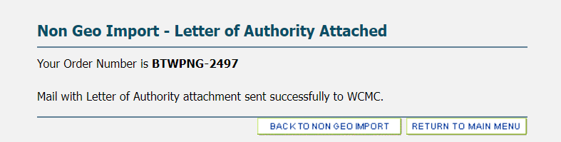

Should you attach a document in error please contact the IP Exchange service desk via eChat Contact us | BT Wholesale advising the order should be rejected. Once rejected, a new porting request can be placed.

Email notifications are sent throughout the import and export journeys to acknowledge/confirm the action requested, and acceptance or rejection of the submitted order.

If the port request is rejected, we will provide details of the rejection codes as stated within the NGNP end to end process manual Non-Geographic Number Portability (offta.org.uk)

NGN orders are amended and cancelled via the Number Management Portal following the same format and timescales as the geographic porting but selecting the options via the Non-Geographic Number Porting menu.

Problems during NGNP Porting & Emergency Restorations

As with geographic porting, the Emergency Restoration Order can be used by the GCP to restore service to a ported customer when full service has not been provided following the attempted port. Any request for emergency restoration will be dependent upon the LCP agreeing to take the number back and may be requested up to close of business the day following the activation of the port.

These requests can be made by email to the IP Exchange service desk wolverhamptonnumberportability@bt.com, quoting the telephone number to be restored and the restore reason.

The GCP should also contact the IP Exchange service desk via eChat Contact us | BT Wholesale selecting the emergency restore option. The IP Exchange service desk will request the Emergency Restoration and will inform the GCP if the LCP has agreed.

Should the request for investigation be outside of the initial 48 hours following port completion, please raise a fault via the BT Wholesale Voice Products Ordering and Support Systems app accessed via www.btwholesale.com.

Non-Geographic Number Export

The service allows the export of any non-geographical number that has been imported to the BT CUPID 001, that has been sub-allocated from a BT number range, or that is from a CP owned range managed on the IP Exchange Type A service.

Following acceptance of a number export request for a previously imported number or for a sub allocated number, the BT IP Exchange service desk will provide you as the LCP with an AOT email notification to advise you when the export is due to take place.

If you as the LCP successfully retains your end user customer, you should send an email to the IP Exchange service desk via wolverhamptonexport@bt.com to advise the export request should be cancelled. This will be sent to the GCP.

Where you as the IP Exchange Type A CP have sub allocated numbers to a Reseller and an export has been requested, it is your responsibility to inform the Reseller of the port date/time.

Please see the CP Own Allocated Numbers section 9 within this document regarding the porting of numbers from a CP owned range managed on the IP Exchange platform.

CP Own Allocated Numbers Deployed on IP Exchange (EXPORT)

CP own allocated number ranges are ranges allocated directly to a CP by Ofcom. They may include geographic and non-geographic ranges. The managed number portability service offered by BT to IP Exchange Type A billed CPs can be used to facilitate export requests for any number(s) from a non-BT allocated range managed via an IP Exchange Type A billed service.

Where you as the IP Exchange Type A CP have sub allocated numbers to a Reseller and an export has been requested, it is your responsibility to inform the Reseller of the port date/time.

It remains the Rangeholder’s responsibility to ensure the Emergency Services Database is updated. Details of how to do this are contained in the IP Exchange Product Handbook found via IP Exchange - Products & services | BT Wholesale.

Any ports carried out using this service will result in the IP Exchange platform automatically routing these calls directly to the GCP and not via your network. You as the RH need to consider calls originating on, or routing via, your own network. Such calls should either be routed to IP Exchange or direct routed to the GCP.

On-Net Export to IP Exchange 001 including Subsequent Port

If a request is received for your CP own allocated number(s) managed on your IP Exchange Type A service to export to 001 (via another Type A CP or BT directly), as the RH you will receive an AOT.

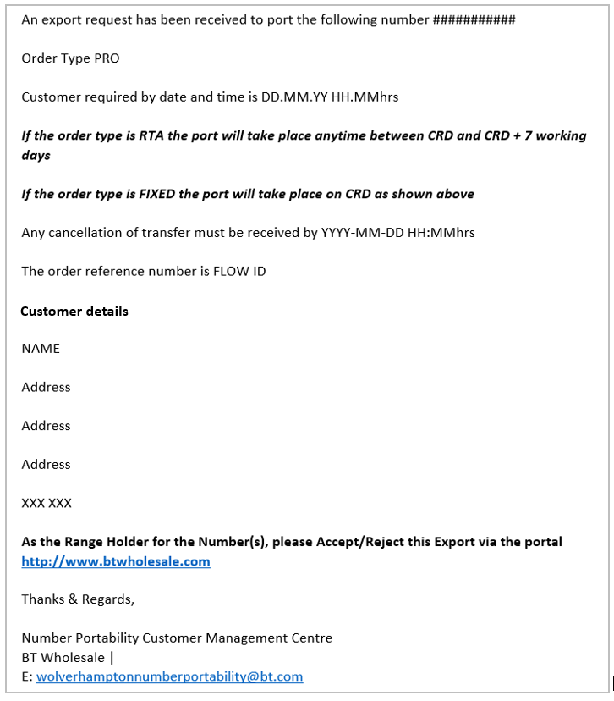

As a Type A CP, you can choose to Accept or Reject the order via the IP Exchange App, selecting the Accept/Reject CP Own Number Port Request option. Search via the order reference number.

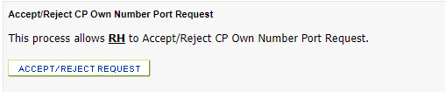

The CUGID will auto-populate. Enter the order number as stated on the AOT.

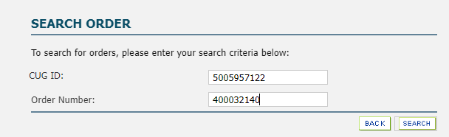

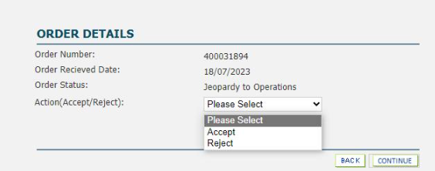

Orders can only be rejected based on incorrect or missing information being presented by the GCP.

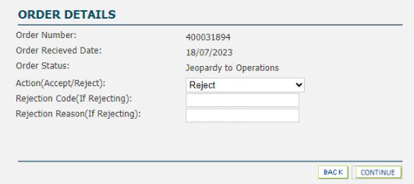

The primary reject code can be added in the Rejection Code field with further codes included within the Rejection Reason field as required.

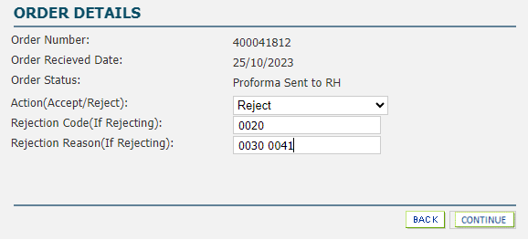

If rejection code 0015 ‘Other’ is chosen, please include an explanation for the use of this reject code.

If you choose to accept the order, the order will then be progressed as per the GCP port order request.

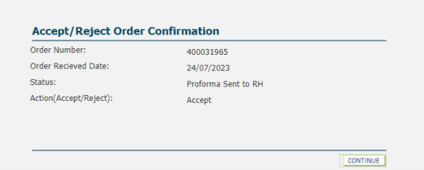

Where your CP own allocated number(s) managed on your IP Exchange Type A service has previously ported to 001 and a request is received for a subsequent port to another party associated with 001, the LCP will receive an AOT to advise when the export will take place. No notification is sent to the RH/Hosting CP as no routing changes are required.

Off-net Export including Subsequent Port

Any request to export a number from one of your own allocated geographic or non- geographic numbers to a non-IP Exchange Type A CP will come to you directly from the GCP.

It is your choice as to how you wish to facilitate that request. As a Type A CP, if you have no direct physical interconnection in place with the GCP, you may decide to make use of the routing solution available via the number management portal. When agreeing commercial arrangements with the GCP, please note that Type A does not support the use of transit (505XXX) prefixes.

Any requests in relation to another CP’s number ranges made directly to BT cannot be progressed and will be rejected with the advice to contact the range holder.

It is the responsibility of you as the RH to keep the GCP informed of order progression throughout the order journey.

The following instructions for the routing solution service supports both geographical and non-geographical and are applicable for both the single and multi-line journey, whichever is appropriate, as per the GCP request.
The same steps apply for a CP own allocated number previously exported either on-net or off-net, and now being subsequently ported to another off-net CP.

From the IP Exchange App main menu, select EXPORT CP OWN NUMBERS

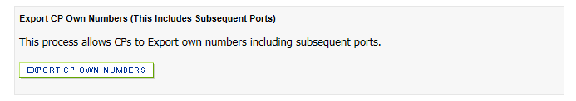

Select Geographical / Non-Geographical as appropriate.

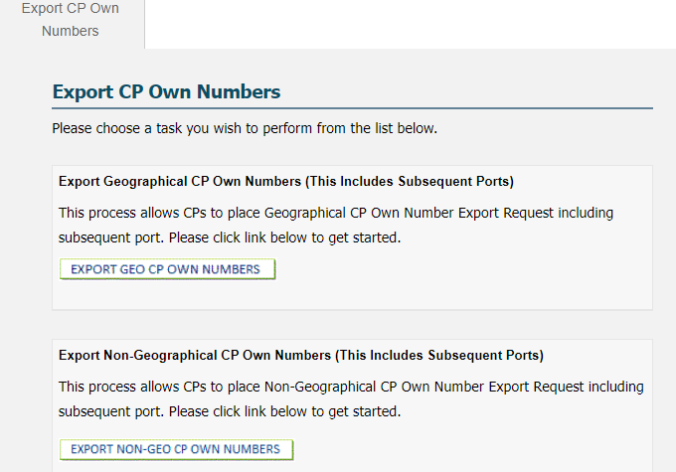

Select the Single Line or Multiline Export as appropriate.
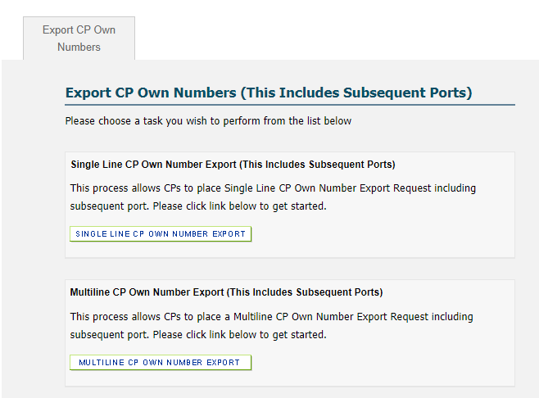

Select Place CP Own Number Export.

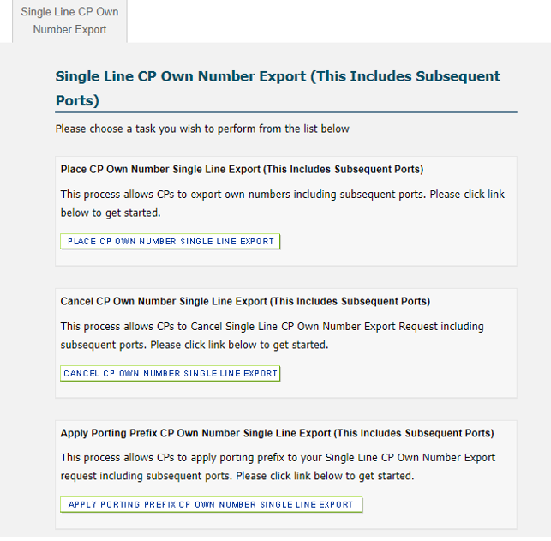
Enter the details as per the port request you have received directly from the GCP – single line as follows below.

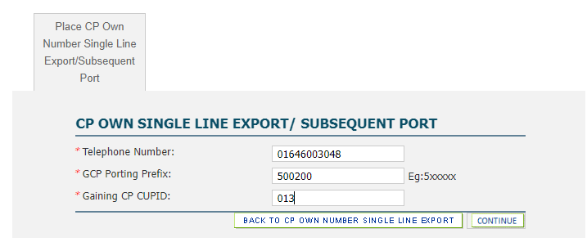

For multiline requests, enter the main billing number and subsequently include each range and any associated numbers.

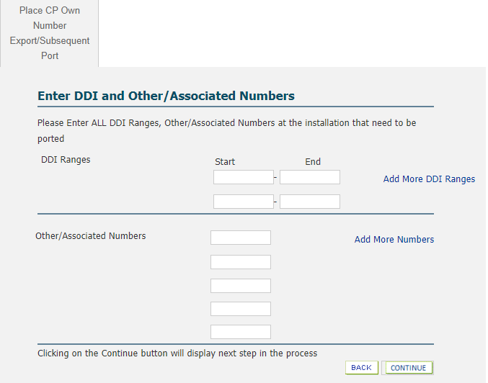
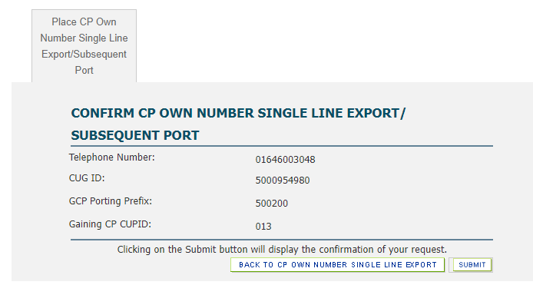
You will be presented with the Order Submitted screen with confirmation of your export order number.

You, as the RH, receives the Order Accepted KCI email notification showing the order as being “Accepted” and advises the action required on the date of port.

It is your responsibility to keep the GCP informed of order progression throughout the order journey.

Example of Order Acceptance email

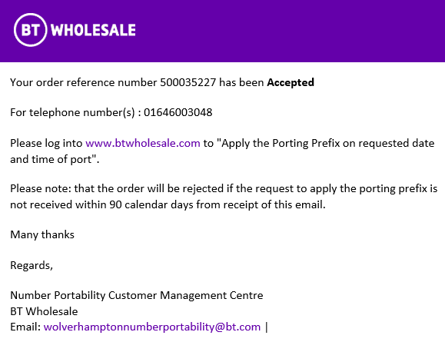

On the required day of port as requested and agreed with the GCP, you as the RH, select “Apply Porting Prefix CP Own Number” for Single or Multiline as applicable

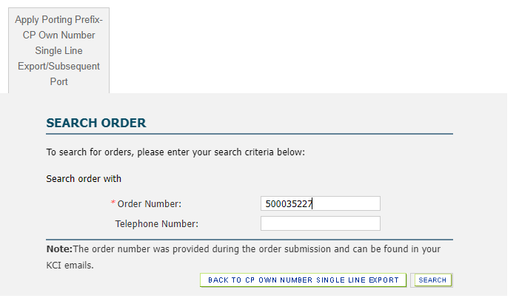

Click to apply the porting prefix as per the details on the agreed port request you have received directly from the GCP.

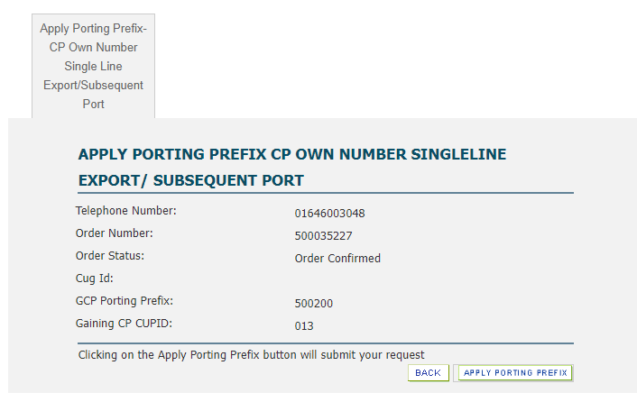

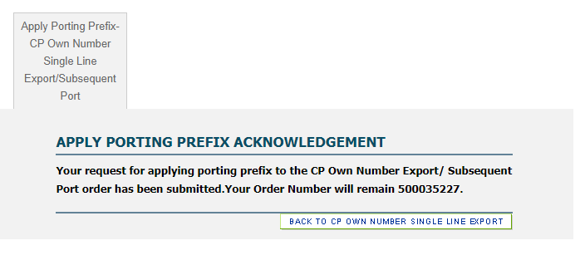

The order will be rejected if the request to apply the porting prefix is not received within 90 calendar days from order acceptance. A new order will be required if the export is required to go ahead via the portal.

It remains the Rangeholder’s responsibility to ensure the Emergency Services Database is updated. Details of how to do this are contained in the IP Exchange Product Handbook found via IP Exchange - Products & services | BT Wholesale.

If there is a fault with a CP own number that has exported to a non-IP Exchange Type A CP, you as the IP Exchange RH should raise the fault request on behalf of the GCP and keep the GCP informed of progress if you believe the fault lies within the BT network.

Return to Rangeholder Requests

Any cease requests for your own allocated number(s) previously exported off-net will come to you directly from the current network operator and you may decide to make use of the routing solution available via the number management portal.

These ‘Return to Rangeholder’ requests should be placed as an import order. Follow the same steps as per a standard single or multi-line request made when a number(s) is gained from another CP (as stated earlier in this document) but using your CUGID and DG to return the number(s) back to you as the RH.
(See section 7.1 for Single or section 7.2 for multi-line)

Any numbers within your own ranges that have previously exported away from you but are now returning to you as a working service should be placed as an import order following the same steps as per a standard single or multi-line request made when a number(s) is gained from another CP.

Cancel Off-net Export

An accepted order for a CP own number export request that is no longer required can be cancelled via the CANCEL option within the relevant Export CP Own Numbers options searching via the order number.
- Select Export Geo CP Own Numbers or Export Non-Geo CP Own Numbers as appropriate.
  - For Geo, then select Single Line CP Own Number or Multiline CP Own Numbers as appropriate to view the CANCEL option.
  - For Non-Geo, the CANCEL option will be immediately visible.

Alternatively the request will time expire after 90 days.

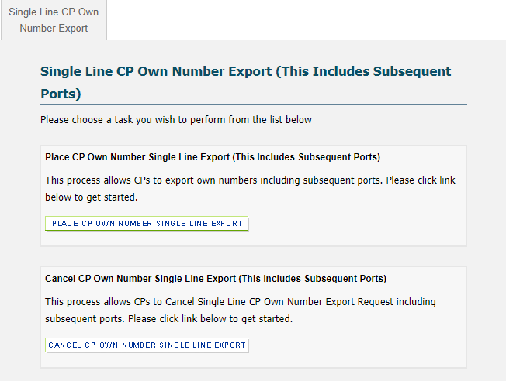

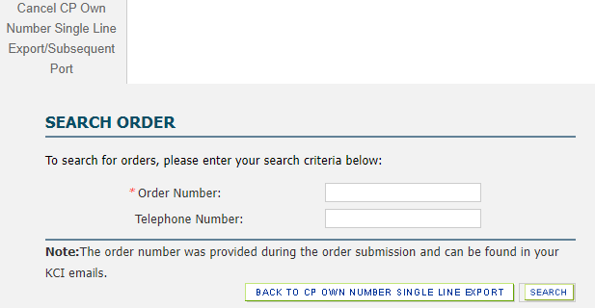

Directory Data

When a telephone number is ported, ownership of the directory data on the Directory Management System is transferred to the GCP. For further information please refer to the IP Product Handbook for the supply of directory data available at IP Exchange - Products & services | BT Wholesale.

Emergency Services Database (ESDB)

It is the CP responsibility to obtain from their end user customers accurate and reliable caller location information for every telephone number. This information is used to keep the Emergency Services Number Database (ESDB) up to date.

The supply of this information must be provided as frequently as is necessary to ensure that the current postcode and address information is available to the Call Handling Agency at the time that the emergency call is answered. It is the responsibility of the CP to ensure that this information is acurate to ensure the safety of endusers. If a 999 call is made from the number(s) and the ESDB is incorrect it may lead to the emergency services going to the wrong address.

For further information please refer to the IP Product Handbook for how to get 999 service established and information on 999 audits available at IP Exchange - Products & services | BT Wholesale.

Completed porting orders will generate an update request to the ESDB. Updates can be rejected based on incorrect information being presented by the GCP within the port order with email notifications sent for each porting journey to confirm acceptance or rejection.

Example of ESDB Rejection email

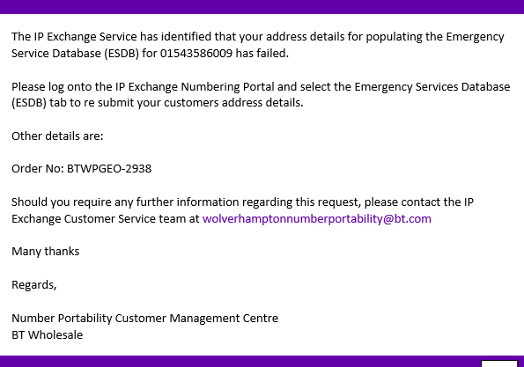

To correct the information supplied, select the ESDB AMEND option via the main IP Exchange menu, searching via the porting order reference.

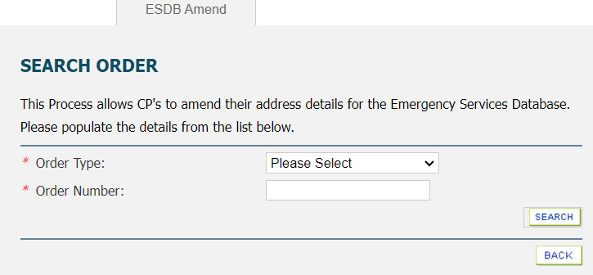

Future changes to the ESDB data can be maintained using the ‘Premises Move’ option via the main IP Exchange menu.

Premises Move

A change to the end user’s installation address should also be reflected in the associated ESDB data entry.
ESDB data can be maintained using the ‘Premises Move’ option via the main IP Exchange menu.

Choose to update your Geographic or Non-Geographic numbers.
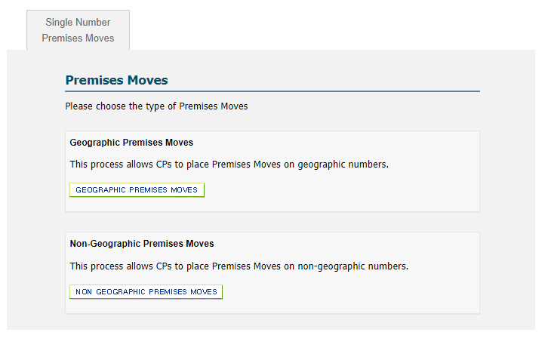
Choose to update your Single or Multiple numbers.
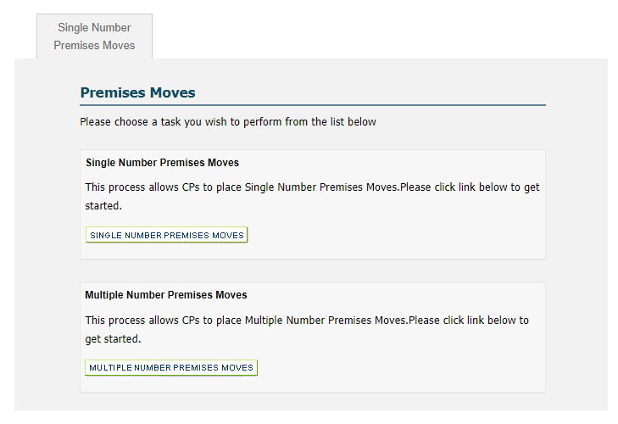

If requesting a Multiple Number Activation, the numbers must be contiguous. You will need to enter both the first and last number of the range.

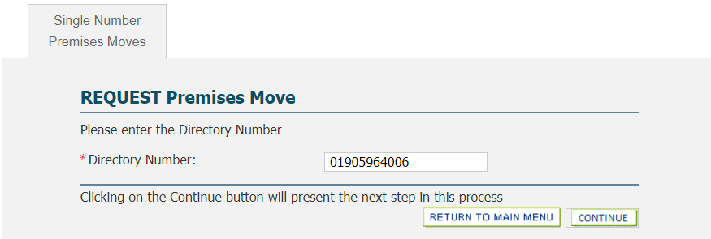

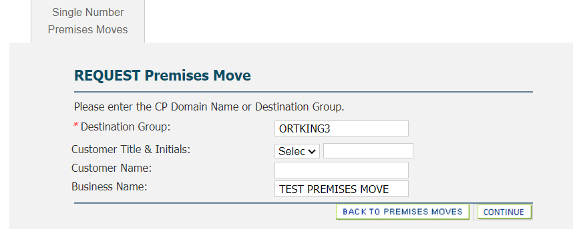
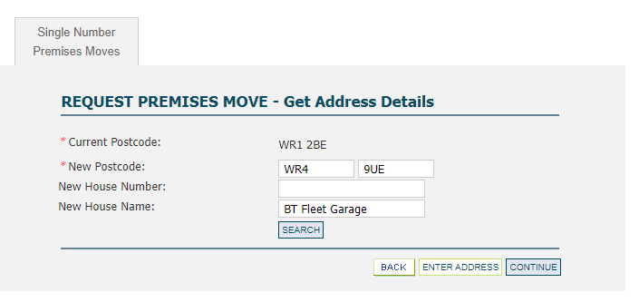
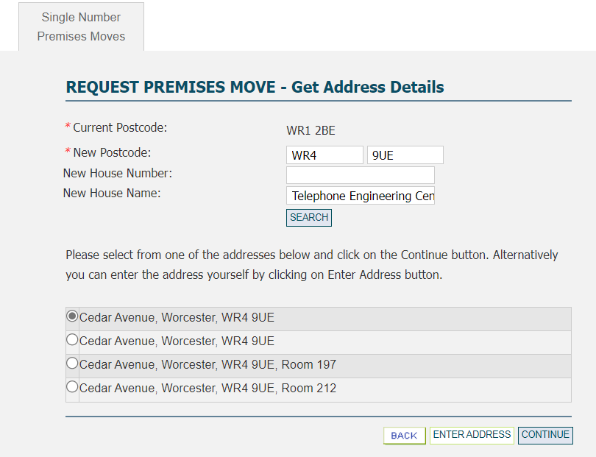

Enter the current postcode and house name/number, click the required match, and select “Continue”.
If a match is not found, select “Enter Address” to manually enter the full address.

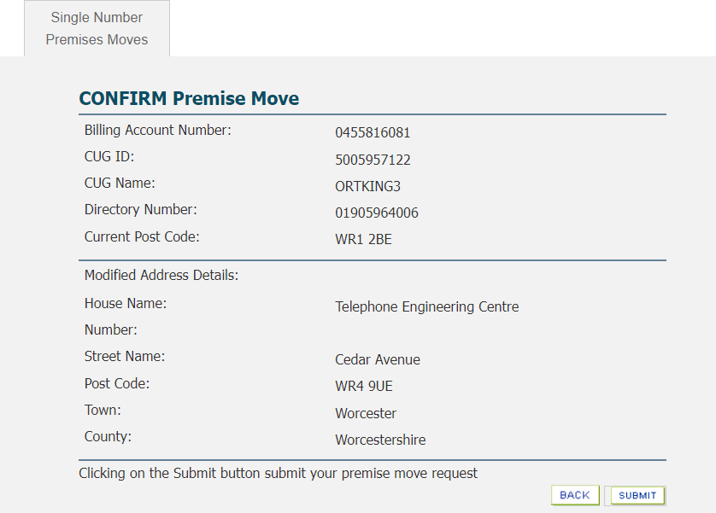

Select “Submit”.

You will then be presented with the Activation Acknowledgement screen.

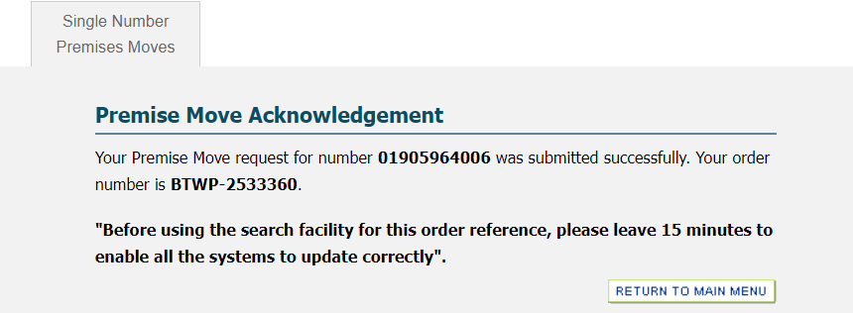

Please leave 15 minutes to enable all systems to update with the revised address details.

Fault Handling and Repair

Faults should be raised via the BT Wholesale Voice Products Ordering and Support Systems app accessed via www.btwholesale.com.

Access and user guides are available within the Support & Tools / IP Exchange Repair portal guides section via IP Exchange - Products & services | BT Wholesale

Should the above app be unavailable, the IP Exchange Repair team can also be reached via email at ipexchangesupport@bt.com or telephone number 0800 077 8247 (option 2) and from outside the UK (+44) 1473 336646.

Repair handling teams will check for known platform problems, record the fault instance, and inform operations of the problems and request a resolution. The system(s) will be updated, and the customer notified of the service restoration on completion.

Notifications

Once a porting request has been submitted, you will receive a series of emails confirming acknowledgement, acceptance/rejection, and completion of the order.

Example of Port Rejection email

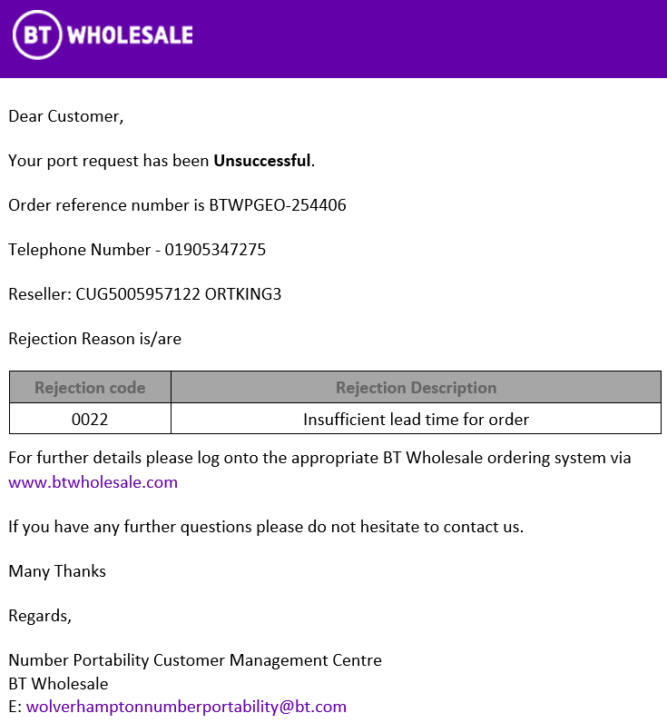

Example of Port Acceptance email

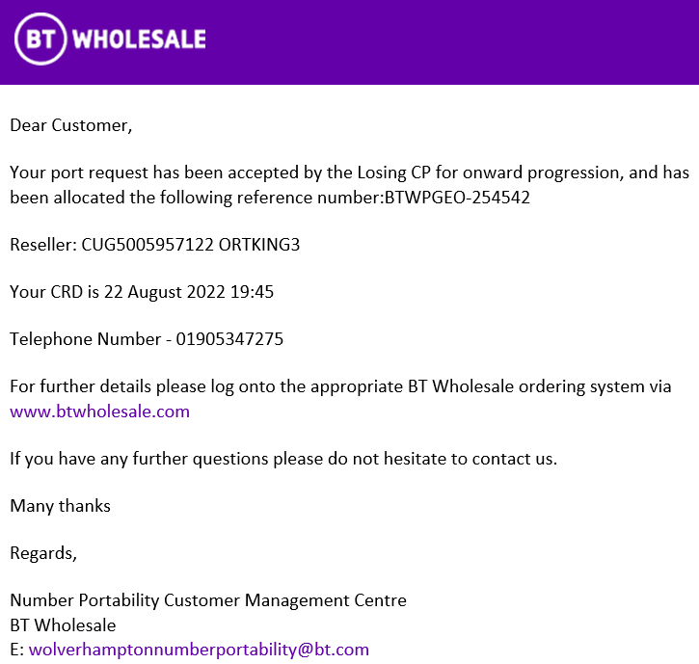

Example of Port Completion email

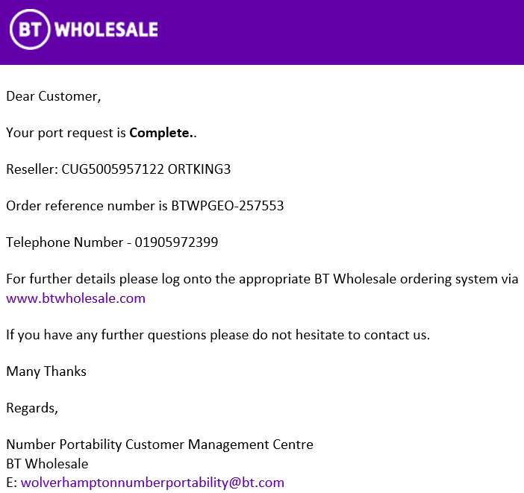

In addition, as porting requires some CP intervention (configuration & activation of a port for example), you may also receive emails instructing you on any activities that need to be undertaken.

Example of Single Auto Postpone Pending Activation email

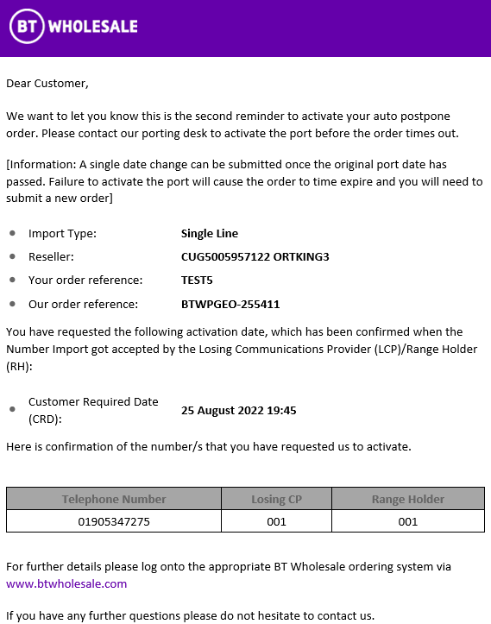

Example of Multiline Pending Activation email

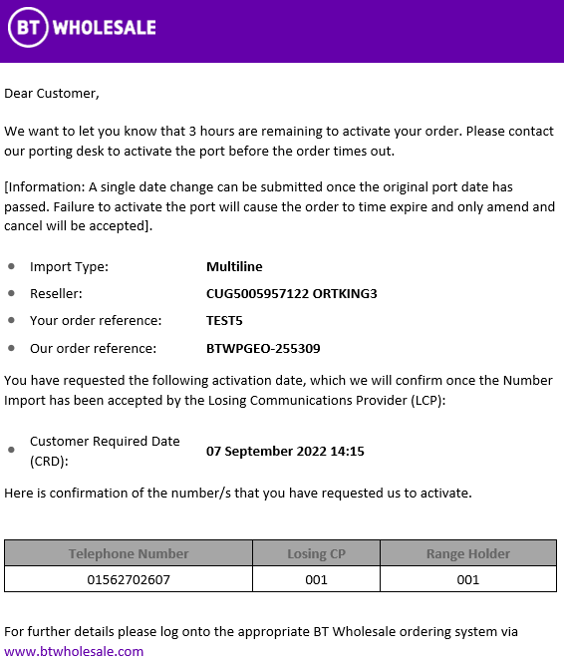

Keeping Customer Informed (KCI) and Advice of Transfer (AOT) emails are sent to the email address as provided within Section 1.7 of the Customer Requirement Form (CRF) – Advice of Transfer (AOT) email address.

Any changes to this email address should be sent to wolverhamptonnumberportability@bt.com advising both the existing and new email addresses, and the relevant CUGID.

Once the change has been made, all notification emails for new orders will be sent to the new email address. Any inflight orders will continue to send updates to the original email address.

Please note that changes to the email notifications sent throughout the sub allocation number allocation, activation & deactivation journeys follow a separate process as detailed in section 7 of the sub allocation handbook found via IP Exchange - Products & services | BT Wholesale

Number Management Portal General Enquiries

The progress of submitted port requests can be tracked on the BT Wholesale Number Management Portal and answers for the majority of queries can be found via IP Number Porting FAQs - Help & support | BT Wholesale.
If you cannot find the answer to your query, the IP Exchange service desk can be contacted via
- e-mail wolverhamptonnumberportability@bt.com
- eChat Contact us | BT Wholesale – selecting the IP Voice chat icon

eChat is available 8:00 am to 6pm Monday to Friday, excluding UK Bank Holidays.

Please send one number port order query per email and include the main billing number in the subject header of any emails you send. Use of the keywords below within the email subject field will assist with routing the email query to the correct team members -

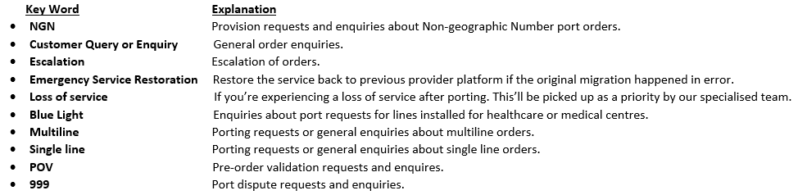

Complaints Handling

Any complaint regarding the IP Exchange service should in the first instance be directed to the IP Exchange service desk for resolution. Should a CP remain dissatisfied they should follow the escalation procedure detailed in their Customer Service Plan https://www.btwholesale.com/help-and-support/customer-service-plans.html#voice-services-csps

Glossary of Terms

AOT | Advice of Transfer
COT | Cancel Other (port request)
COW | Cancel Own (port request)
CP | Communications Provider
CRD | Customer Required by Date
CRF | Customer Requirements Form
CUG | Customer User Group
CUPID | Communications Provider Identification Code
DDI | Direct Dialling In
DG | Destination Group
ESDB | Emergency Services Database
EMR | Emergency Restoration
FAQ | Frequently Asked Questions
GCP | Gaining Communications Provider. The Communications Provider with the network that the Number is to be ported to
GNP | Geographic Number Portability
IP | Internet Protocol
KCI | Keeping Customer Informed (email notifications)
LoA | Letter of Authority – also Customer or DDI Letter of Authority
LCP | Losing Communications Provider. The Communications Provider with the network that the Number is to be ported from.
NGN (P) | Non-Geographic Number (Portability)
NPOR | Number Portability Order Request
Off-net | CP Owned and BT legacy networks, i.e. any network that is not IP Exchange
On-net | BT IP Exchange
OOH | Out of Hours (Porting)
OTA | Office for Telecommunications Adjudicator
PBX | Private Branch Exchange
POV | Pre-Order Validation
PSTN | Public System Telephone Network
RH | Range Holder
RTA | Real Time Activation
SDEDs | Secure Data Transfer Service
VoIP | Voice over the Internet Protocol
WLR | Wholesale Line Rental

Useful Websites for Number Porting

- Ofcom Numbering Site - CPs can determine the Range Holder of numbers they wish to port by referring to the Ofcom published list. This is available at: Telecoms numbering - Ofcom

- Number Portability Industry Process - The industry agreed End to End Process manual can be found by accessing the following link, Best practice guidance | OTA (offta.org.uk)

APPENDIX 1 SOGEA Integrated Porting with IP Exchange A

Outline of the Service Changes

This appendix to the IP Exchange Number Portability Handbook is for a CP who has ordered a SOGEA integrated port and requires the telephone number to be ported to their IP Exchange A account.

An Integrated Number Port involves the export of a telephone number from a working WLR service as part of a migration from WLR to SOGEA. The number is activated on the CPs IP Exchange A service in line with the Openreach activity undertaken as part of the SOGEA order. When placing your SOGEA order you should request the IP Exchange prefix 519158.
Please note this service is only available for single line ports.

Before requesting an integrated port on IP Exchange, you must first order SOGEA as an integrated port and have received the KCI2 ‘Order Committed’ notification confirming the contractual delivery date.

The same delivery date option should be chosen for both orders with the recommended option being Auto-Postpone. The delivery dates for both orders must always either align exactly or fall within the auto-postpone porting window. If Auto-Postpone is chosen, you are advised to activate the IP Exchange port request once the appropriate SOGEA notification is received from Openreach.

There are no direct links to the SOGEA ordering with Openreach. It is your responsibility for raising both the SOGEA & IP Exchange orders and coordination of the activities for both, such as date change or cancellation. Date changes must always adhere to the minimum lead-times.

If the integrated port option has been selected in the SOGEA order, the integrated port option must also be used for the IP Exchange port order.

Ordering Process and Provision

Access the IP Exchange App via access to www.btwholesale.com

From the IP Exchange App main menu, select SINGLE LINE IMPORT
From the Single Line Import menu, select PLACE SINGLE LINE IMPORT

Select ‘No’ against “I am the current provider and require an IPEX number transfer” to display the SOGEA Integrated Port option.

Select ‘Yes’ against the SOGEA option to follow the SOGEA Integrated Port journey.

This option should only be selected where you have already placed a SOGEA order as an integrated port and received the KCI2 ‘Order Committed’ notification confirming the contractual delivery date.

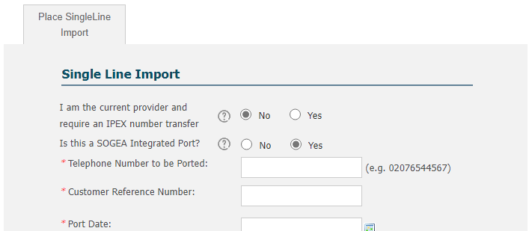

The port date and time should match that of the SOGEA ‘Order Committed’ KCI2 to ensure both actions are coordinated, and service is not affected. Minimum lead times must be adhered to.

Auto-postpone is the recommended option as the date given on the IP Exchange porting request is the start of the seven working day porting window. This provides more flexibility as no amendment is required for the IP Exchange order should the SOGEA order be delayed for a time within that seven-day porting window. If your SOGEA order is delayed for more than the auto-postpone porting window, you are responsible for amending the IP Exchange order in line with the revised SOGEA date.

Please note: Any delay notifications for the SOGEA order must be checked against the IP Exchange order to ensure the delivery dates align or fall within the auto-postpone porting window.

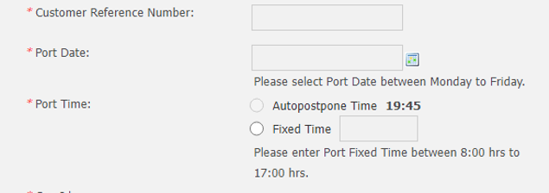

The following error message is shown if the number entered is not valid for an integrated port, i.e. it is not working with and owned by Openreach,
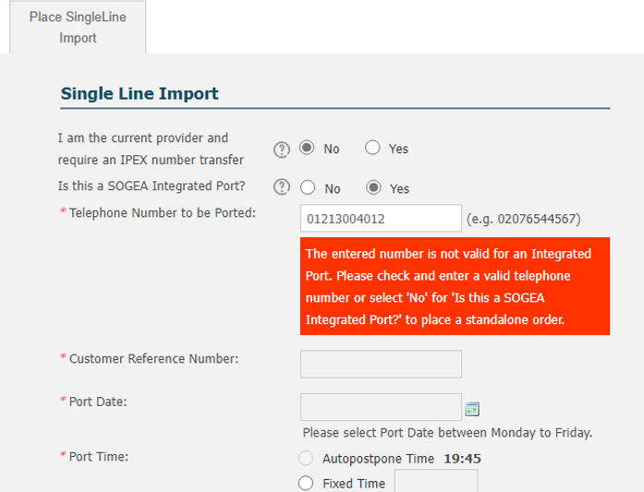

All fields are disabled until either the number is corrected to follow the integrated order journey or the SOGEA Integrated Port option is set to ‘No’ to follow the standalone single line import journey.

Complete the remaining fields as per a standard single line import.

Basic validation checks will be made against the IP Exchange records, but no checks made via Openreach.

Once the IP Exchange porting request has been submitted, you will receive the standard IP Exchange notifications such as acknowledgement, acceptance / rejection, and completion, advising the status of your order.

If you should cancel your SOGEA order, you must also cancel your IP Exchange port request to ensure service is not affected.

Day of SOGEA Completed Install & IP Exchange Number Port

19.3.1 Real Time Activation/Auto-Postpone Ports

Real time activation/auto-postpone ports require an activation trigger via the portal. Three email reminders are sent from the CRD onwards advising the porting window has started. No action should be taken until the SOGEA order is confirmed as working. Either notification code 101185 confirming field task completion or KCI3 Order Complete (both from Openreach) can be used as the notification to trigger your IP Exchange port activation. You should then login to the IP Exchange Portal to activate the real time activation port.
CPs should not activate the port prior to being informed that SOGEA has completed as this will result in loss of service.

You must activate the number via the IP Exchange Number Management Portal using the ‘Activate Single Line Import’ option from the Single Import menu. This ensures the number to be ported is configured on the IP Exchange Core Routing Engine

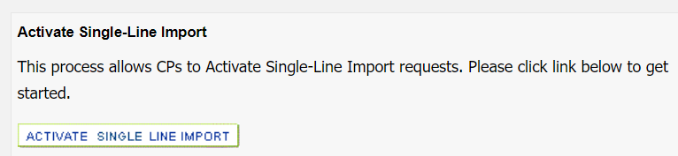

If the port isn’t activated within the porting window and the CRD left unchanged, the IP Exchange port will trigger automatically at CRD+7 21:00 irrespective of the status of the SOGEA order.
It is your responsibility to keep the dates aligned on both orders to ensure service is not affected.

In the unlikely event a rejection KCI is received following the auto postpone activation request for your Integrated Number Port for SOGEA, please contact the IP Exchange service desk for assistance via Contact us | BT Wholesale – selecting the IP Voice chat icon
The IP Exchange service desk will provide assistance resolving the issue preventing the port request progressing.

19.3.1 Fixed Time Ports

Fixed time port requests automatically take place on the date and time as stated on the GCP order. Openreach will apply the IP Exchange Porting Prefix in their network for the number to be ported. The IP Exchange routing engine will be configured for that number at the time indicated on the porting order.

Fault Handling and Repair

Upon receipt of the SOGEA Completion Notice, any service issues should be raised with Openreach in the first instance and not the IP Exchange Porting Helpdesk.

This information will cease to be relevant once WLR service is withdrawn.

Wherever we refer to Openreach, this relates to your supplier of SOGEA which may not be Openreach directly, for example your SOGEA supplier may be BT Wholesale or another party.
All SOGEA KCI and Notification Code information is correct at the time of writing.

