“eQuery User Guide”

Contents

Overview 3
Adding Attachments/Comments to the raised query 11
Submitting Attachments/Comments 12
Checking details 13
Query details page 14
Viewing Attachments 22

Overview
This document contains the user guide of the eQuery Management Tool through the eBilling application to enable BTW customers to raise their billing/invoice related queries through eBilling application on BTWholesale.com.
Initially this is being launched as a trial, and as part of this trial we would ask you to supply some feedback through your normal billing contacts. There may be some teething problems as we go through the first month, but please bear with us and flag any issues to us as soon as you can.

Pre-requisite
The customer before raising/viewing the query should/must have the below requisites
- The customer should be a valid eBilling application customer with their portal ID’s mapped to the relevant account number
- The customer should have access to eQuery application through BTWholesale.com

Note: For gaining access to the above pre-requisites, Kindly drop a mail to btwholesale.direct@bt.com

Login to Portal
A user should first login to the portal with the following steps
- Hit the URL and then click on login link on the uppermost right hand corner.
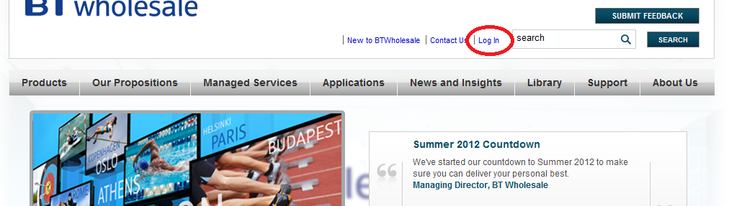

- Enter the valid credentials for the login
Note: If you do not have a valid credential, Please drop an e-mail to btwholesale.direct@bt.com
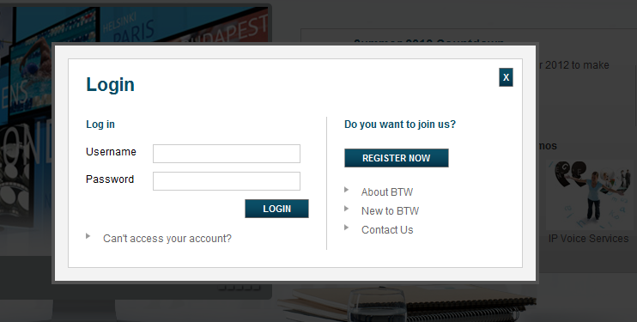

- Click on the confirm button on the CMA page.
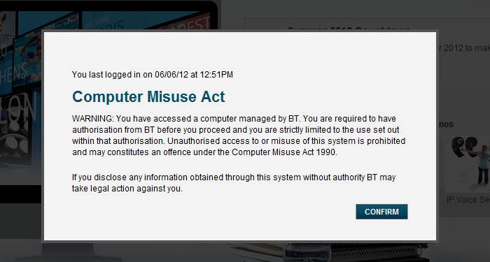

- Navigate to Applications> My Applications.
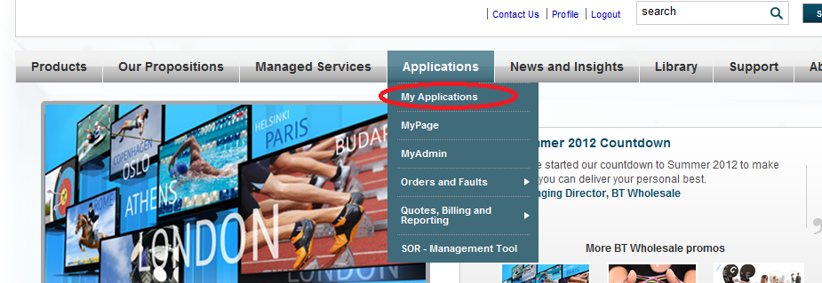

- Under Customer zone e-Billing application would be present click on the application.
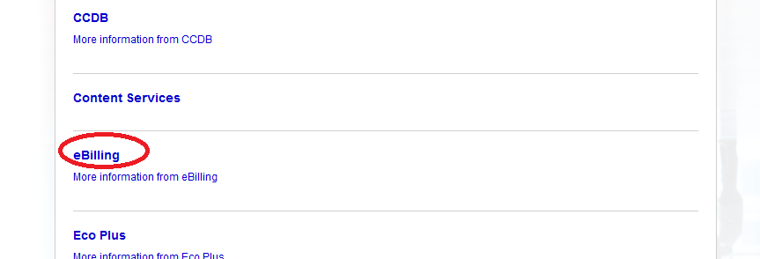

eBilling Homepage
On BTW Customer zone page, you will see eBilling as an application, Clicking on this will take you to the home page of the application where user can:
- Raise the Query for the current/previous bills
- View the Query for the current/previous bills
- Search a specific Query

Raising query on current bill
Clicking on the marked “Raise Query” link will take the user to the page allowing them to fill in necessary details and proceed with raising their query for the current bill only.
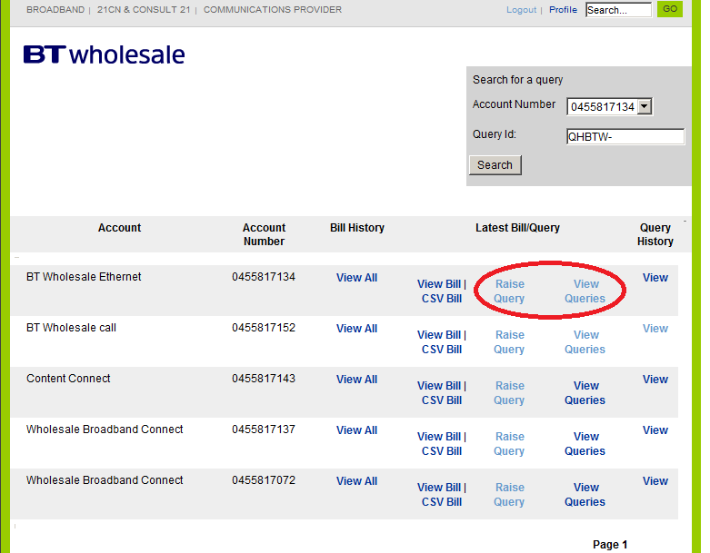

To raise a query, enter the required information and click on “Create” button to create the query. To cancel or go back to the eBilling homepage, the user can click on “Back to eBilling Homepage” button.
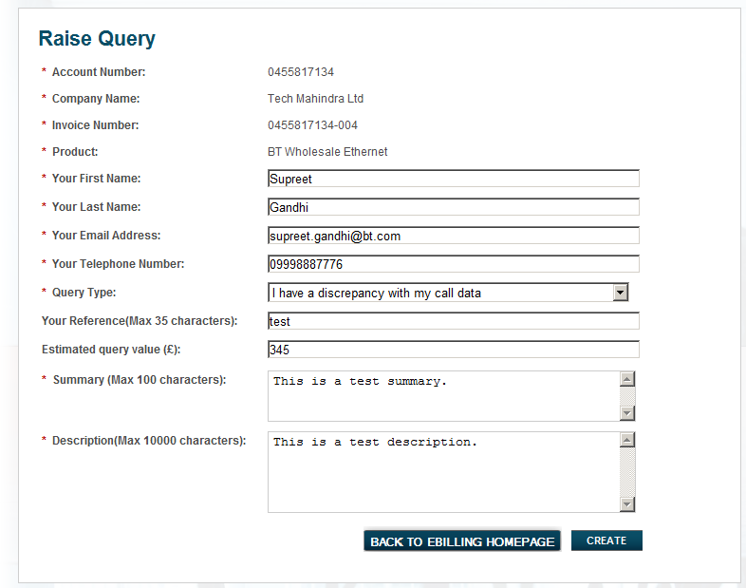

Raising query on previous bill
Clicking on “View All” option (as indicated) under bill history on the eBilling homepage will list all the previous bills of the customer.
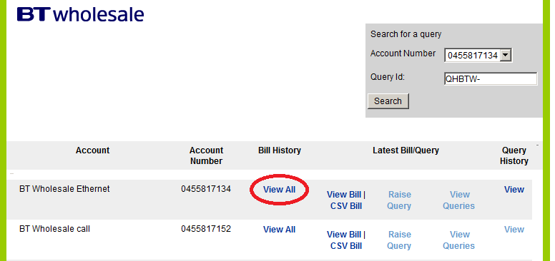

Clicking on the marked “Raise Query” link will take the user to the page allowing them to fill in necessary details and proceed with raising their query against a specific previous bill.

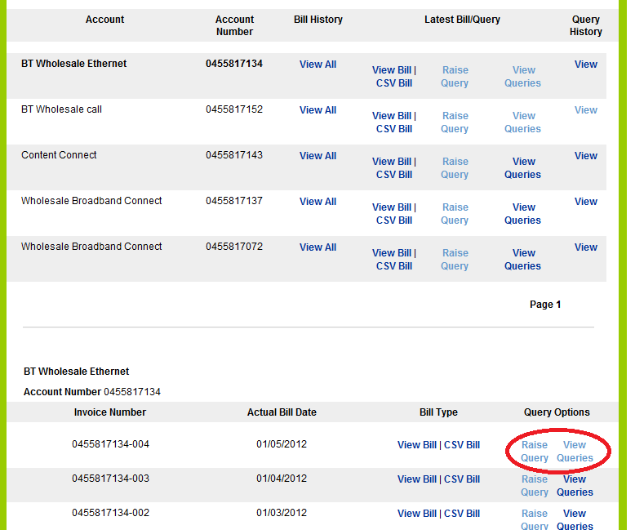

Adding Attachments/Comments to the raised query
On the next page the user will be given a confirmation message for successfully raising the query and the opportunity to support the query with an attachment or a comment
Note : 1> The maximum size of the attachment can be up to 5 MB and can be added one at a time
2> view comments option on the query details page would display 10 latest comments on the query.

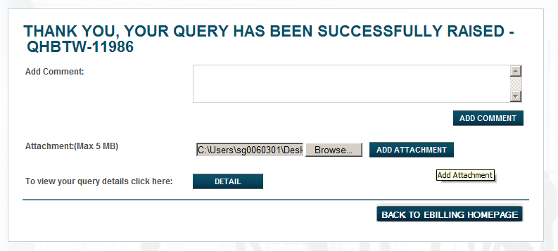

Submitting Attachments/Comments
Clicking on Add Attachments/Add Comments button will submit the attachment/comments to the BTWholesale billing team and will store the data with a confirmation page displaying to the user as shown below.

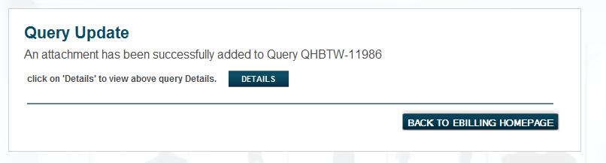

Checking details
Clicking on the details button (as indicated) would re-direct to the detailed summary page of the query raised and user can then view the details and can add further attachments and comments.
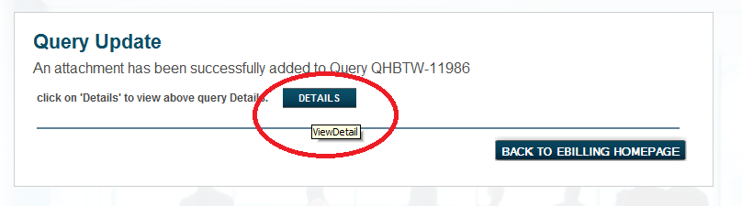

Query details page
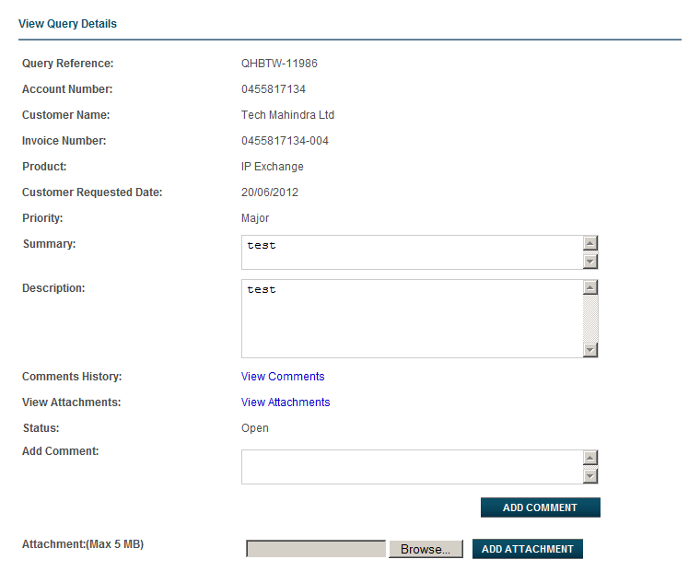

Closing the Query
Clicking on the “Close Query” button would close the existing query and would give a confirmation message to the user as below.
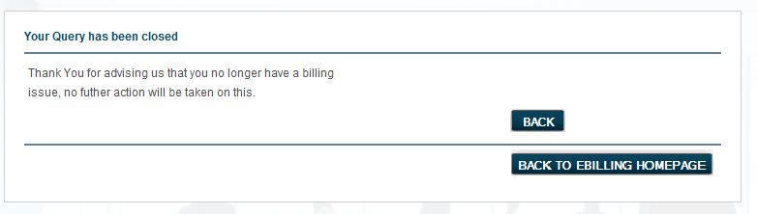

View Query on current or previous bills

Clicking on the marked “View Query” link will display a list of the queries raised against the current bill only of the corresponding account number .

Clicking on the marked “View Query” link would take the user to a page that will display a list of the queries raised against a specfic bill of the corresponding account number .

Selecting a query and clicking on the marked “View Query Details” button, present on the above page, will navigate to the query details page
(Page containing the list of queries)
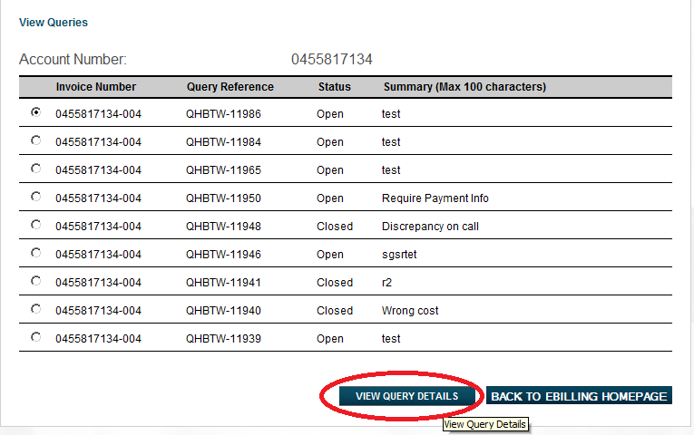

Display of selected query’s details

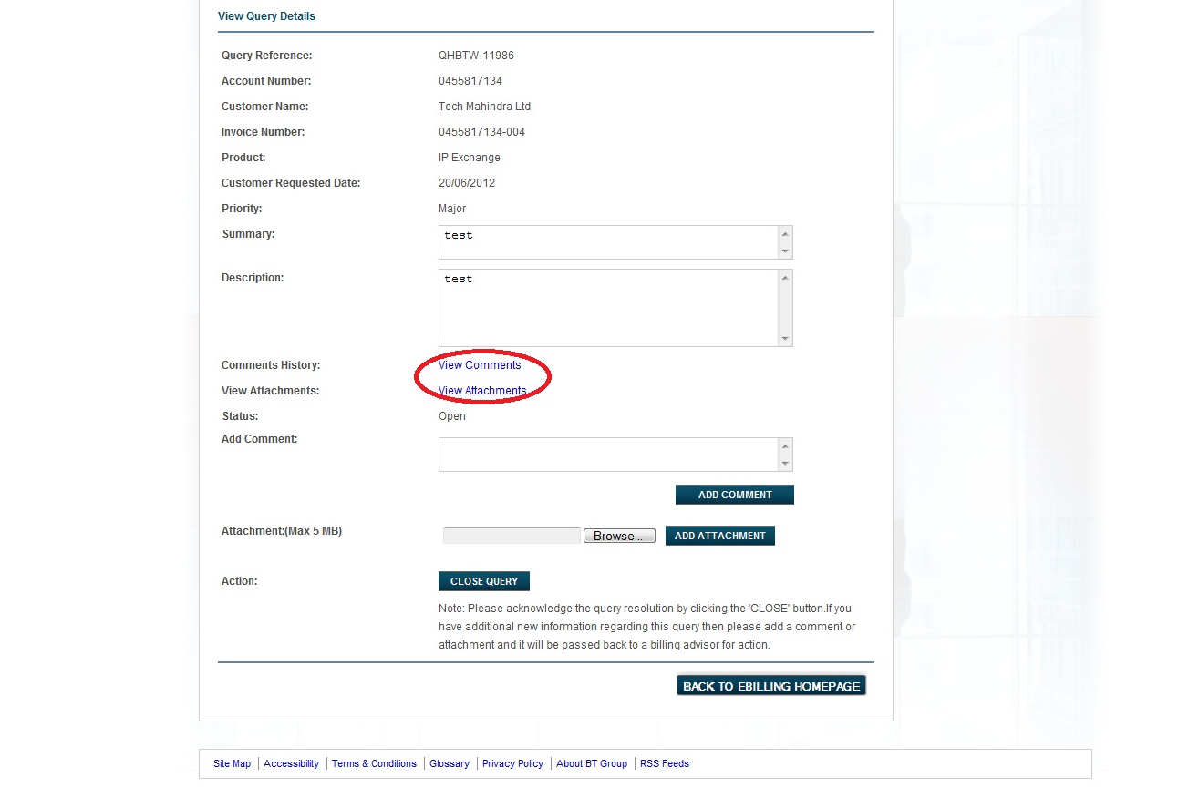

Viewing Comments
Clicking on the View comments (as indicated) above on the query details page will display the latest 10 comments available for that particular query on a single page as shown below.
Clicking on “View All Comments” will display all the comments added to the query.

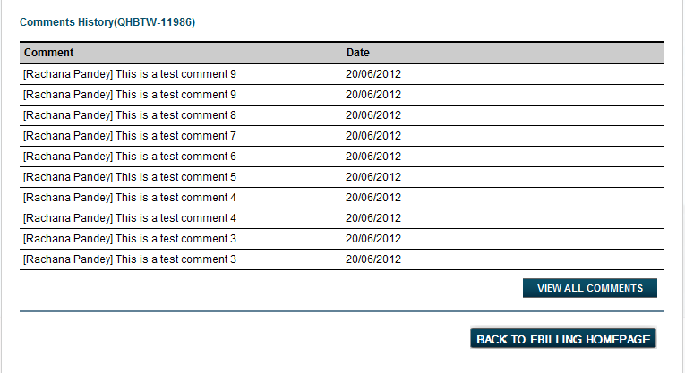

Viewing Attachments
Clicking on “View Attachments” from the query details page will navigate to the page below and the user can view the attachments on the page.

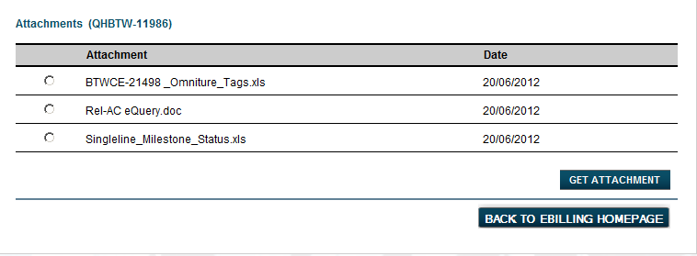

Viewing Specific Attachment
Selecting the radio button for any of the attachment to be viewed and clicking on the “Get Attachment” button will create a pop-up box allowing the user to save or open the document to be viewed.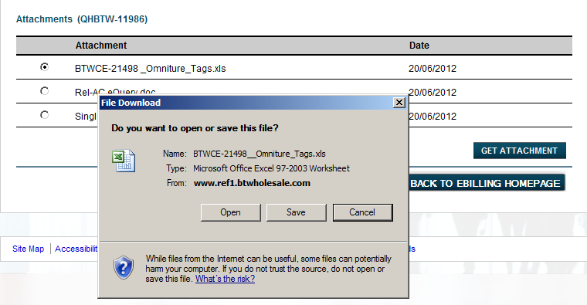

Search a specific query
Selecting an account number from the ‘Account Number’ drop down, entering a query id (eg:QHBTW-11986) against the Query Id field and clicking on the marked “Search” button will take the user to a search result page.
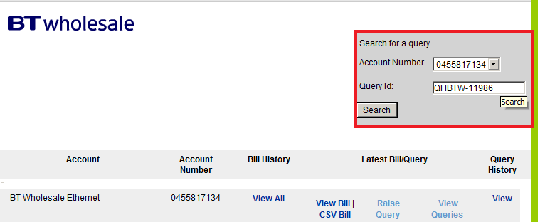

Selecting the query and clicking on View Query Details button on the search result page will navigate to the query details page.
(Search Result Page)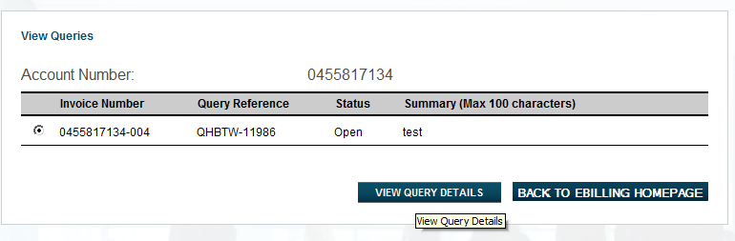

Query Details Page

